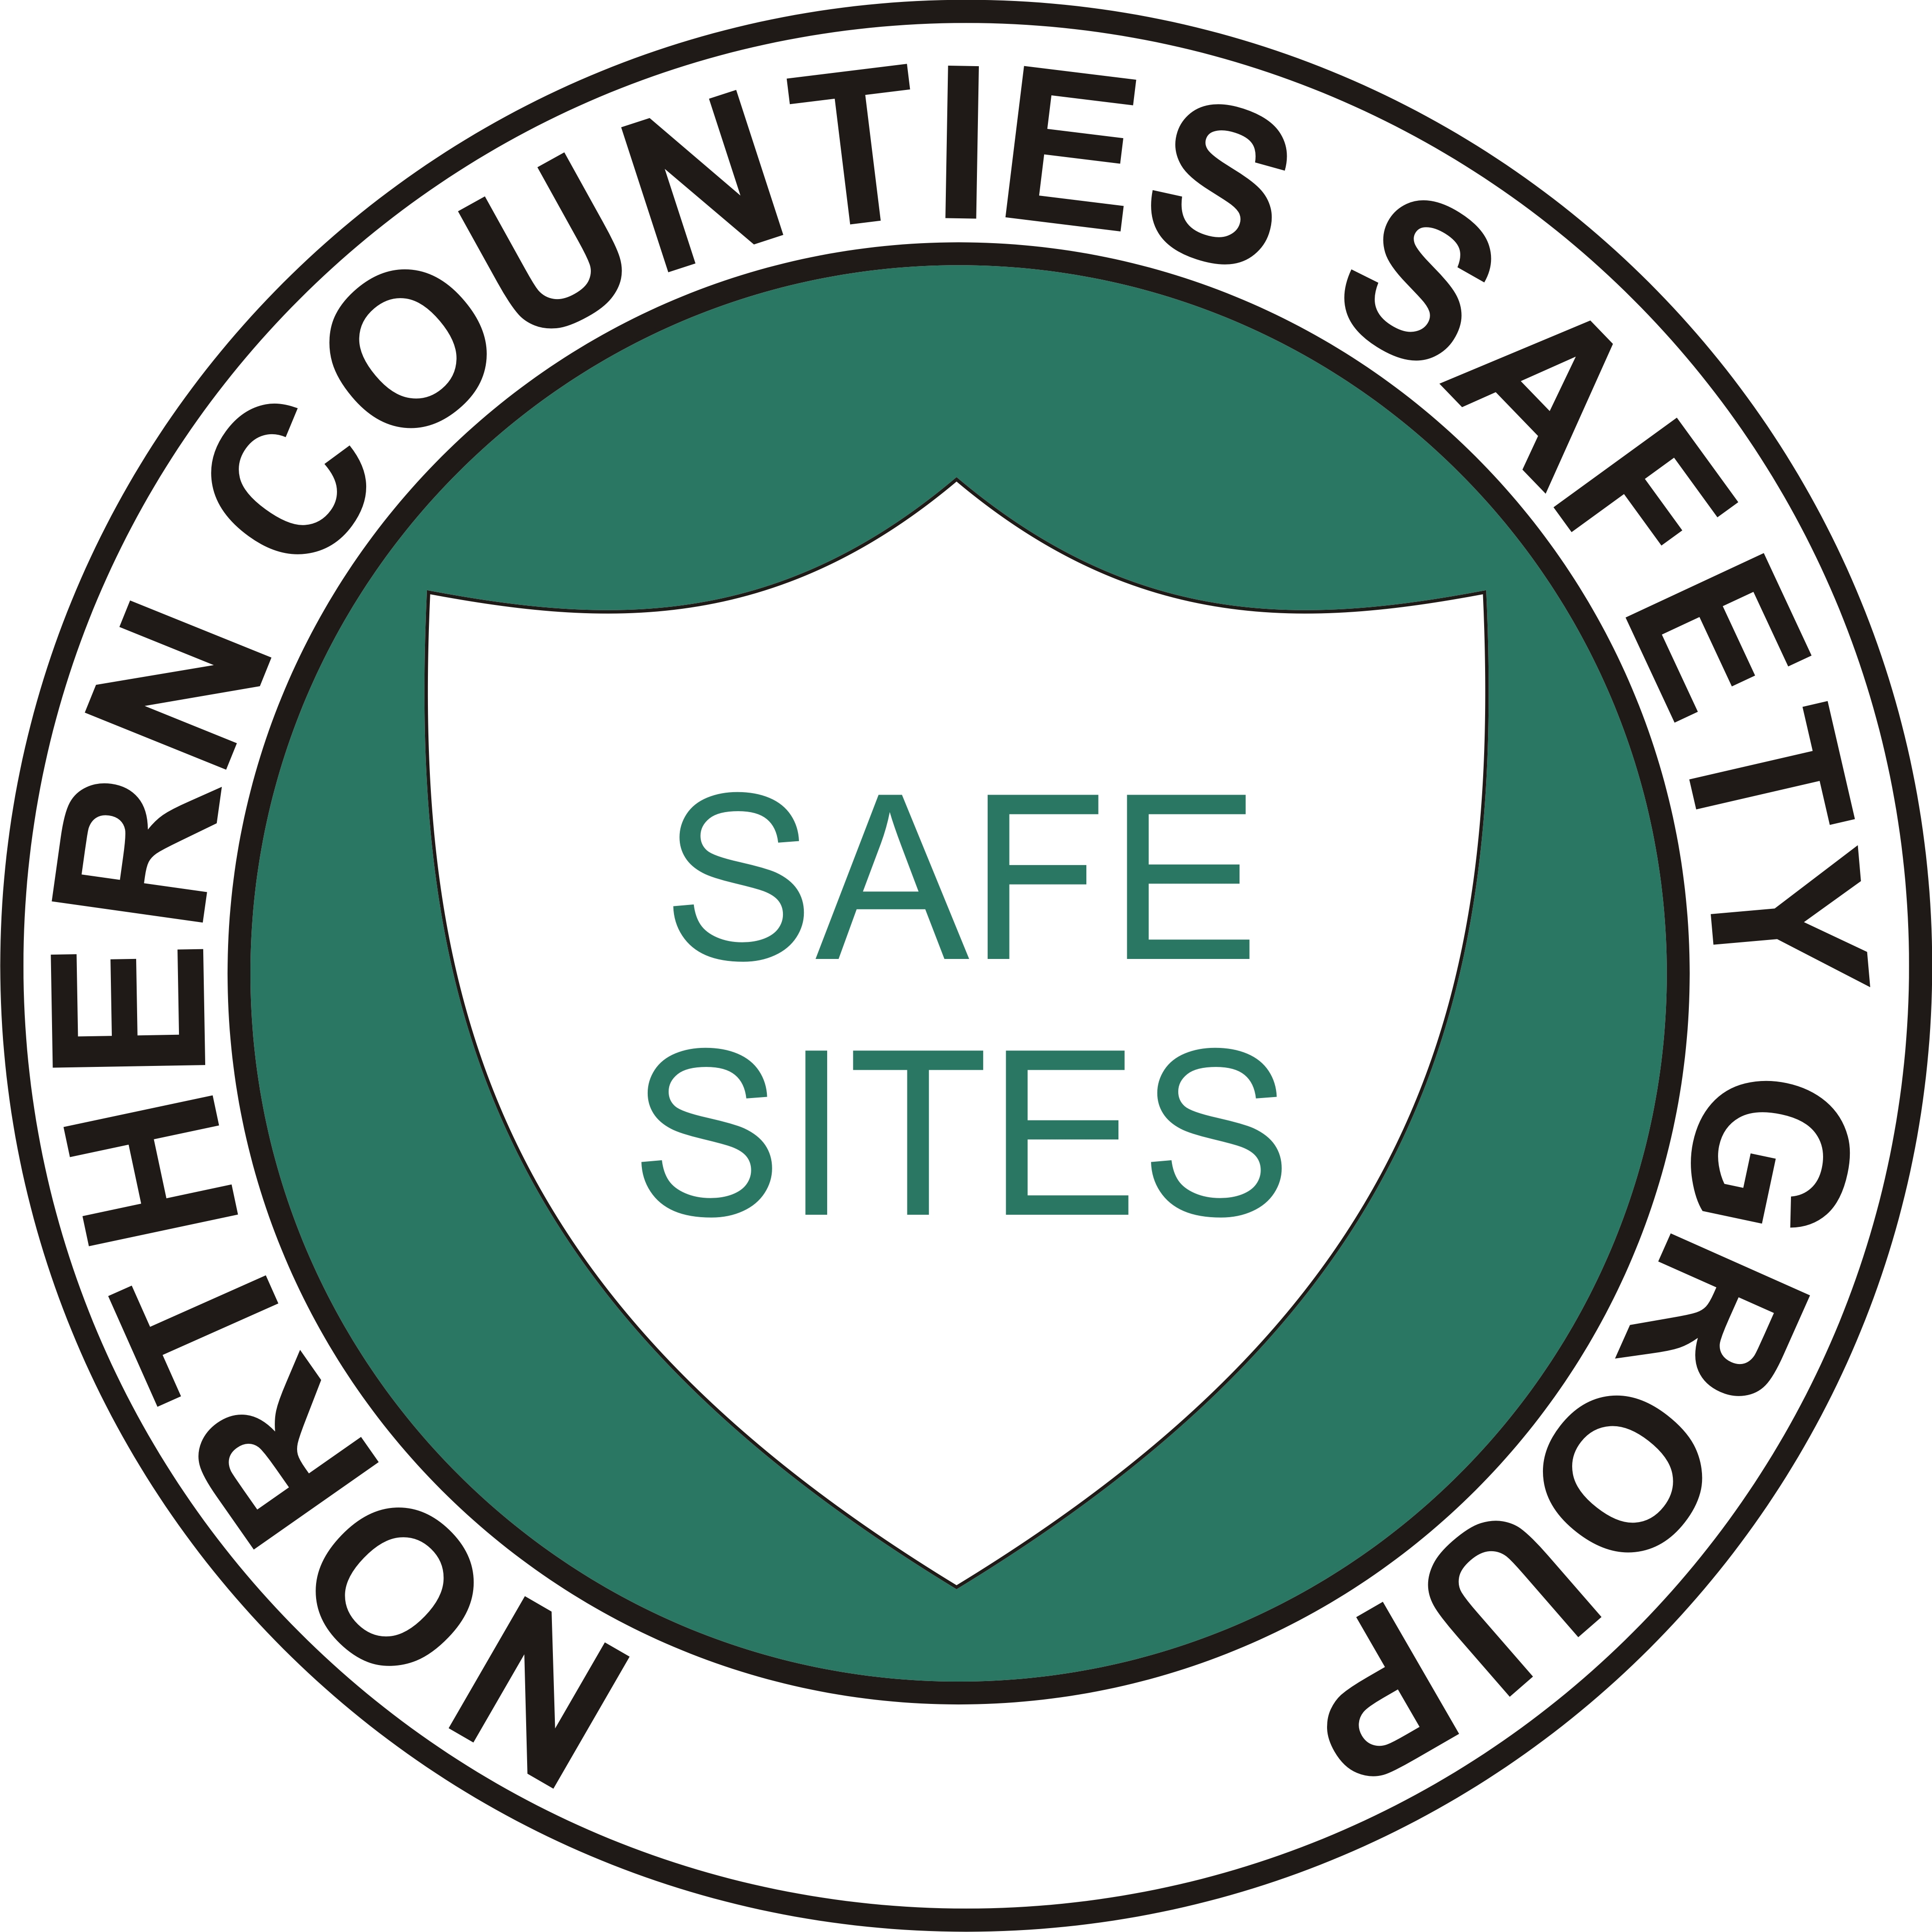
NORTHERN COUNTIES
SAFETY GROUP LIMITED
Safety Training & Services to the Construction Industry

FACTSHEET

Working at Height

Introduction
This course of training will enable supervisors who manage work at height to perform their duties safely in compliance with The Work at Height Regulations and other supporting Regulations and guidance

Course Aims
To emphasise to delegates the employer’s statutory duty to have ‘competent persons’ using suitable work equipment; and to enable the delegate to select and use the equipment correctly in a safe manner.

Objectives
At the end of the course delegates will be able to:-

- Appreciate that falls from height can be costly, both in monetary and personal injury costs by showing examples of poor practice
- Understand the need for ‘Safe Systems of Work’ under HSAWA by learners being able to explain what a safe system of work is and draw up a safety method statement / risk assessment.
- Understand the basic requirements of the Working at Height Regulations and the hierarchy of fall prevention and control
- Knowledge of how the legislation applies to roof work, MEWP’s, scaffolding, towers, the use of ladders and step ladders; and how some of these items must be ‘last resort’ options for work
- Knowledge of the basic techniques for managing harnesses and fall arrest systems.
- Gain practice in using ladders, step ladder and understand the use of fall arrest equipment in the work environment.
- Demonstrate knowledge retention by passing the written end of course questionnaire

Delegate Numbers
A maximum of 18 delegates will be permitted per instructor as this course involves an element of practical work.

DURATION – ½ Day

