Site: |  |  |  |  |  |  |  | Contract Number:
Assessed by: | Name: |  |  | Position: |  |  |  |  | Date:
 | Signed:
Description Of Work: | Cutting openings in internal walls of an existing structure.
Task / Job Component | Hazard |  | Persons at risk |  |  | Risk Rating L/M/H | Controls / Precautions to Reduce Risk |  |  |  | Residual Risk Rating  L/M/H
Forming openings in internal walls. | Manual Handling. |  | Demolition Workers, machine operators, unauthorised visitors. |  |  | H | Training in safe manual handling techniques.  - Provide clear access routes to work areas.  - Removal of large blocks of material by machinery.  - Provide rubbish chutes to dispose of waste materials or skips on wheels suitable for moving by forklift.  - Provide wheelbarrows. |  |  |  | L
 | Dust. |  | Demolition Workers, machine operators, unauthorised visitors. |  |  | H | Controlled wetting of the surfaces exposed.  - Safety glasses or goggles.  - Use dustless equipment, i.e. fitted with extractors.  - Forced air movement.  - Consider alternative methods of cutting which produce less dust such as wet cutting diamond chainsaw.  - Wear a respirator |  |  |  | L
 | Asbestos. |  | Demolition Workers, machine operators, unauthorised visitors. |  |  | H | Carry out pre-demolition/refurbishment survey.  - Asbestos awareness training and emergency plan.  - Removal by licensed contractor |  |  |  | L
 | Fall of material. |  | Demolition Workers, machine operators, unauthorised visitors. |  |  | H | Provide scaffolding.  - Establish and police exclusion zones.  - Suitably strengthened internal floor, propped if necessary. |  |  |  | L
 | Electrocution. |  | Demolition Workers, machine operators, unauthorised visitors. |  |  | H | Suitably protected 110v supplies and frequent user inspection and portable appliance test.  - Use of battery equipment. |  |  |  | L
 | Noise. |  | Demolition Workers, machine operators, unauthorised visitors. |  |  | H | Provision and enforced wearing of high quality ear defenders when above 85dB(A)  - Use low noise and remote cutting or breaking equipment, e.g. diamond chain saws.  - Use machine mounted tools if feasible. |  |  |  | L
 | Contact with services. |  | Demolition Workers, machine operators, unauthorised visitors. |  |  | H | Carry out physical survey to identify locations of all services.  - Remove prior to work commencing, obtain certificate of isolation or disconnection where appropriate or provide sturdy temporary protection. |  |  |  | L
 | Unauthorised access |  | Demolition Workers, machine operators, unauthorised visitors. |  |  | H | Temporary covers.  - Barriers and signs. |  |  |  | L
 | Slips, trips and falls. |  | Demolition Workers, machine operators, unauthorised visitors. |  |  | H | Provide safe access routes.  - Good housekeeping  - Edge protection where there is a risk of falls at edges or openings.  - Good lighting.  - Safety footwear. |  |  |  | L
 | Collapse of structure. |  | Demolition Workers, machine operators, unauthorised visitors. |  |  | H | Supervision and carrying out of the work by suitable, experienced and competent person.  - Calculations by engineer and site inspection.  - Planned sequence of operations, drawings and manufacturer’s instructions for any temporary support and system for transfer of demolition materials to minimise surcharges to structure.  - Inspection before and during use of any support equipment. |  |  |  | L
 | Falls from Height or through fragile materials. |  | Demolition Workers, machine operators, unauthorised visitors. |  |  | H | Maximise the use of any remote cutting techniques.  - Install and maintain edge protection and working platforms or work from mobile elevated working platforms (MEWPS) or similar.  - Identify unsafe areas by signs and barriers. |  |  |  | L
 | Vibration White Finger (VWF). |  | Demolition Workers, machine operators, unauthorised visitors. |  |  | H | Provide system for monitoring health of operatives when exposed to above the daily action value of 2.5m/s2  - Use modern well maintained equipment, keep hands warm, avoid smoking. |  |  |  | L
 | Explosions. |  | Demolition Workers, machine operators, unauthorised visitors. |  |  | H | Safe area for storage of any gas and use of gas cutting gear by trained persons only with flashback arrestors and non-return valves with bottles secured against tampering and fall. |  |  |  | L
 | Dermatitis. |  | Demolition Workers, machine operators, unauthorised visitors. |  |  | M | System for monitoring skin condition, wearing gloves or waterproof barrier cream. |  |  |  | L
Site-specific Activities | Additional Site–specific Hazards |  | Persons at risk |  |  |  | Additional Controls Required

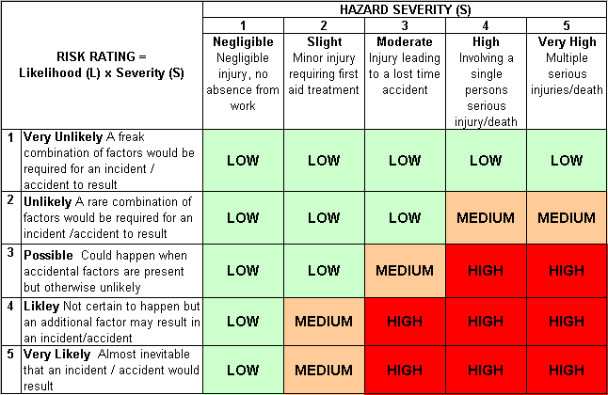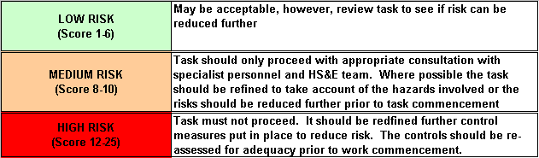Likelihood
How often could the hazard occur? Consider the task, frequency, duration, method of work,
employees involved.

Severity

How serious would the hazard’s effects be if
realised? Consider the type of hazard, biological, ergonomic, physical and chemical.

Risk = Likelihood x Severity

E.g. Likelihood (4) X Severity (3) = 12 HIGH RISK

