Site: |  |  |  |  |  |  |  | Contract Number:
Assessed by: | Name: |  |  | Position: |  |  |  |  | Date:
 | Signed:
Description Of Work: | Lifting/laying of Paving Flags
Task / Job Component | Hazard |  | Persons at risk |  |  | Risk Rating L/M/H | Controls / Precautions to Reduce Risk |  |  |  | Residual Risk Rating  L/M/H
Lifting/laying of 400x400x40 concrete paving slabs | Weight of slab: 14Kg  Repetitive handling  Strains/sprains |  | Operatives carrying out the work |  |  | M | - Slabs to be mechanically handled (JCB/telehandler) as close to area where they are to be laid as possible, to minimise distances carried by hand.  - Flags to be carried using wheelbarrows where possible to area where they are to be laid.  - Correct kinetic lifting techniques to be used by experienced operatives who have had manual handling training.  - Weight of 14Kg well within physical capabilities of operatives who are to lift them. |  |  |  | L
 | Cuts/abrasions to hands |  | Operatives carrying out the work |  |  | M | - Wearing of orange latex coated grip gloves. |  |  |  | L
 | Existing health issues (back injuries etc) |  | Operatives carrying out the work |  |  | M | - Check that operatives do not have existing injuries that might be made worse by the task. |  |  |  | L
 | Slips/trips/falls |  | Operatives carrying out the work |  |  | M | - Areas to be level and free from obstructions |  |  |  | L
Site-specific Activities | Additional Site–specific Hazards |  | Persons at risk |  |  |  | Additional Controls Required

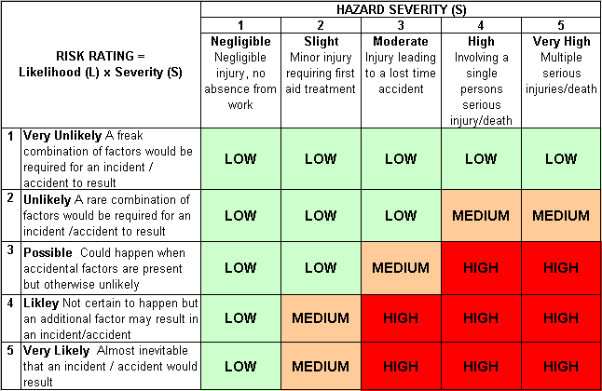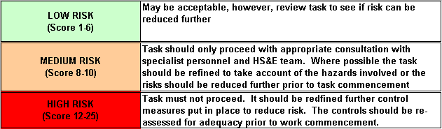Likelihood
How often could the hazard occur? Consider the task, frequency, duration, method of work, employees involved.

Severity

How serious would the hazard’s effects be if
realised? Consider the type of hazard, biological, ergonomic, physical and chemical.

Risk = Likelihood x Severity

E.g. Likelihood (4) X Severity (3) = 12 HIGH RISK

