Site: |  |  |  |  |  |  |  | Contract Number:
Assessed by: | Name: |  |  | Position: |  |  |  |  | Date:
 | Signed:
Description Of Work: | Use of mobile towers using trained erectors
Task / Job Component | Hazard |  | Persons at risk |  |  | Risk Rating L/M/H | Controls / Precautions to Reduce Risk |  |  |  | Residual Risk Rating  L/M/H
Use of mobile towers | Instability - Wind |  | Operatives, 3rd parties |  |  | M | All employees must be tower trained (PASMA preferred)  If wind speed exceeds 17mph cease work  If wind is forecast to reach gale force (40mph) it should be dismantled.  Do not attached sheeting to the tower. |  |  |  | L
 | Instability – Side Loads |  | Operatives, 3rd parties |  |  | M | Assess effects of work to be carried out, for example pressure washing or shot blasting – the maximum allowable side force is 20kg |  |  |  | L
 | Instability – Vertical Loads |  | Operatives, 3rd parties |  |  | M | Only hoist up materials within the effective base area of the tower.  Always consult the instruction manual for guidance |  |  |  | L
 | Instability – Ground Conditions |  | Operatives, 3rd parties |  |  | H | - Assess ground to ensure suitable for tower  - On soft ground use base plates and sole boards in place of castors. |  |  |  | L
 | Instability – Vertical Alignment |  | Operatives, 3rd parties |  |  | M | Level up the tower with the adjustable legs – do not use these to gain additional height. |  |  |  | L
 | Structural Failure – Overloading |  | Operatives, 3rd parties |  |  | H | Do not exceed the Safe Working Load (SWL) of the tower. This will be displayed on the edge of the platform boards and in the instruction manual. Distribute the loads evenly |  |  |  | L
 | Falling from height |  | Operatives, 3rd parties |  |  | H | - Double guardrails and toeboards must be fitted to the tower.  - Operatives must be trained through PASMA  - The 3T (through the trap) method or advanced guardrails must be used to reduce the risk of falls |  |  |  | L
 | Items falling from height |  | Operatives, 3rd parties |  |  | H | - Toeboards must be fitted..  - Hard hats to be worn at all times.  3. Safe storage do not clutter platform. |  |  |  | L
 | Work in public places |  | Operatives, 3rd parties |  |  | M | - Use suitable barriers to prevent unauthorised access, especially if leaving the tower unattended.  - Warning signs must be displayed.  - Incomplete scaffolds must display warning signs and access blocked. |  |  |  | L
 | Striking by Vehicles |  | Operatives, 3rd parties |  |  | M | - Erect suitable barriers and display warning signs.  - Traffic management may be required. |  |  |  | L
 | Moving the Tower |  | Operatives, 3rd parties |  |  | H | - Check the suitability of the intended route to ensure there are no obstructions, both at ground level and overhead (particularly overhead cables.  - All people and materials must be removed and the height of the tower must be reduced in height to 4 metres if stabilisers or outriggers remain fitted.  - Stabilisers should be raised no more than 25mm (1 inch) from the ground.  - If stabilisers or outriggers are removed, or not in there normal working position then the tower must be reduced to a maximum of 2 metres in height. |  |  |  | L
Site-specific Activities | Additional Site–specific Hazards |  | Persons at risk |  |  |  | Additional Controls Required

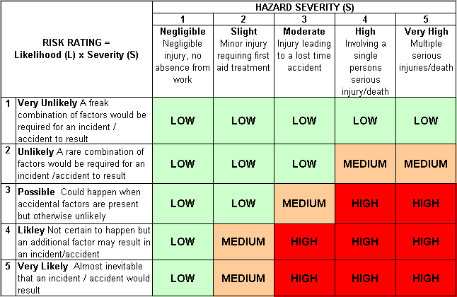
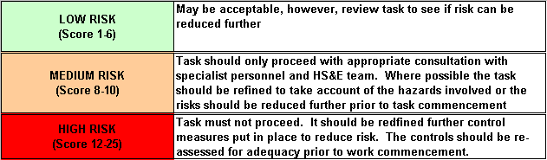
Likelihood
How often could the hazard occur? Consider the task, frequency, duration, method of work, employees involved.

Severity

How serious would the hazard’s effects be if
realised? Consider the type of hazard, biological, ergonomic, physical and chemical.

Risk = Likelihood x Severity

E.g. Likelihood (4) X Severity (3) = 12 HIGH RISK

