Site: |  |  |  |  |  |  |  | Contract Number:
Assessed by: | Name: |  |  | Position: |  |  |  |  | Date:
 | Signed:
Description Of Work: | Oxy-propane cutting
Task / Job Component | Hazard |  | Persons at risk |  |  | Risk Rating L/M/H | Controls / Precautions to Reduce Risk |  |  |  | Residual Risk Rating  L/M/H
Oxy-propane cutting | Manual handling. |  | Operatives, other workers |  |  | H | Training in safe manual handling techniques of oxy-propane, trolleys to be used were practicable  - Provide clear access routes to work areas.  - Provide mechanical handling, i.e. forklift or crane welding equipment onto floor levels or scaffolds.  - Provide sack trucks or assistance for moving equipment and materials.  - Use smallest bottle size suitable. |  |  |  | L
 | Confined spaces. |  | Operatives, other workers, visitors, general public. |  |  | H | Special safe system of work with permit to enter system (e.g. box girders).  - If working in confined spaces or welding in areas with reduced airflow then additional controls such as forced ventilation and confined space training will be required.  - Significant risk of explosion and oxygen enriched environments must be assessed for confined space work. |  |  |  | L
 | Radiation. |  | Operatives, other workers, visitors, general public. |  |  | H | Radiation welding shield with filter.  - Flame-retardant overalls (i.e. non synthetic).  - Welding curtains or screens or signs and fences to reduce the risk of arc eye.  - Safety awareness training on welding style being adopted. |  |  |  | L

Oxy-propane cutting | Fall of material/fall from height. | Operatives, other workers, visitors, general public. | H | Scaffolding or MEWP for safe access  - All scaffolds, edge protection and MEWP must be inspected prior to use or operation.  - In date Scaff tags to be displayed on scaffolds.  - MEWP operators must have IPAF training.  - Establish and enforce exclusion zones and display signs | L
Oxy-propane cutting | Dust/fume/gases risk of respiratory diseases (welders lung, asthma etc) | Operatives and other workers in immediate vicinity | H | Awareness of the risk associated with the material to be cut (COSHH assessment).  - Toxic fume hazards such as Nitrogen Oxide, Ozone, Phosgene, Carbon Monoxide may need consideration in the COSHH assessment  - Work in the open air when possible.  - Remove harmful coatings before cutting.  - Consider health surveillance and respiratory assessments  - Provide portable local exhaust ventilation or on gun extraction if in confined areas.  - Provide good welfare soap, nailbrushes, warm water, towels and rest room.  - Provide suitable welding respirator (FFP3S) or air fed visor and helmet.  - Prohibit eating drinking or smoking in the work area.  - No worker to be under 18 or pregnant employee. | L
 | Fire/explosion/burn injuries. | Welders, other workers, visitors, general public. | H | Safe storage of gas – secured from falling in the vertical plane in a well ventilated area.  - Locked against unauthorised use.  - Operation of a hot works permit, this will normally include the need for a second person on fire watch.  - Move or cover flammable materials including hidden wall linings.  - Ventilate voids that could contain gases.  - Gas monitoring.  - Gas equipment to include non return valves and flashback arrestors and valves that are maintained.  - Remove bottles at night.  - Awareness of the risks associated with flashback.  - Provision of and training related to fire extinguishers and means of raising the alarm.  - Warning signs and contact with the fire brigade  - Stop work at least 30 minutes before leaving work area to permit fire and smouldering check. | L
 | Noise. | Operatives, other workers, visitors, general public. | M | Provide advice and hearing protection if necessary, only a hazard if working in noisy environment above 85dB(A) | L

Site-specific Activities | Additional Site–specific Hazards | Persons at risk |  | Additional Controls Required

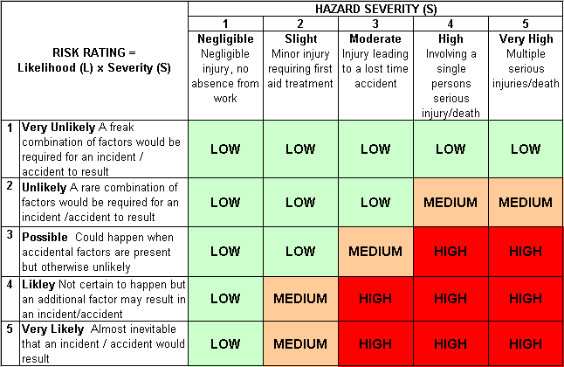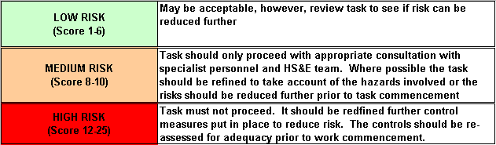Likelihood
How often could the hazard occur? Consider the task, frequency, duration, method of work, employees involved.

Severity

How serious would the hazard’s effects be if
realised? Consider the type of hazard, biological, ergonomic, physical and chemical.

Risk = Likelihood x Severity

E.g. Likelihood (4) X Severity (3) = 12 HIGH RISK

