Site: |  |  |  |  |  |  |  | Contract Number:
Assessed by: | Name: |  |  | Position: |  |  |  |  | Date:
 | Signed:
Description Of Work: | Constructing walls and other high level stone works.
Task / Job Component | Hazard |  | Persons at risk |  |  | Risk Rating L/M/H | Controls / Precautions to Reduce Risk |  |  |  | Residual Risk Rating  L/M/H
Stonework at high level. | Manual handling. |  | Masons, labourers, other workers, visitors, unauthorised visitors, general public. |  |  | H | Training in safe manual handling techniques.  - Provide clear access routes to work areas.  - Provide rubbish skips to dispose of waste materials suitable for moving by forklift.  - Arrange for material to be delivered palletised.  - Arrange for size of material to be specified to suit manual handling.  - Provide wheelbarrows, pallet trucks, sack trucks and hoists and specially constructed loading bays and wide working platforms on scaffolds.  - Arrange for water to be piped to point of use.  - Provide ready-mixed mortar. |  |  |  | L
 | Fall of material. |  | Masons, labourers, other workers, visitors, unauthorised visitors, general public. |  |  | H | Scaffolding, with edge protection.  - Establish and police exclusion zones, install scaffold fans and debris netting.  - Specify safe height for work to progress in a single shift. |  |  |  | L
 | Electrocution. |  | Masons, labourers, other workers, visitors, unauthorised visitors, general public. |  |  | H | Use suitably protected 110v supplies and frequent portable appliance testing.  - Take precautions against contact with services. |  |  |  | L
 | Dust. |  | Masons, labourers, other workers, visitors, unauthorised visitors, general public. |  |  | H | Arrange to work different hours from client.  - Clean using wet methods or vacuum cleaner with high efficiency filters and FFP3 respirator  - Use physical screening to protect passers by.  - Use wet cutting methods or dustless equipment, i.e. fitted with extractors.  - Provide suitable respiratory and eye protection and air-fed helmets if necessary.  - Consider health surveillance. |  |  |  | L
 | Noise. |  | Masons, labourers, other workers, visitors, unauthorised visitors, general public. |  |  |  | Provision and enforced wearing of high quality ear defenders.  - Select quiet equipment, site noisy cutting operations away from other workers.  - Specify machine-cut stone/reconstructed stone direct from suppliers. |  |  |  | L
 | Weather – heat stress from wearing protective equipment in hot weather;  Hypothermia from wind chill, wet conditions and static nature of work. |  | Masons, labourers, other workers, visitors, unauthorised visitors, general public. |  |  |  | Provide designed protective sheeting to external scaffold.  - Provide suitable personal protective equipment (PPE).  - Provision of drinking water, information and monitoring of symptoms.  - Provision of suitable clothing, protective creams and shelter close to the work area. |  |  |  | L
 | Vibration white finger (VWF). |  | Masons, labourers, other workers, visitors, unauthorised visitors, general public. |  |  |  | Provide system for monitoring health of operatives.  - Use modern well-maintained equipment, keep hands warms, avoid smoking and ensure workload is shared. |  |  |  | L
 | Slips, trips and falls from height. |  | Masons, labourers, other workers, visitors, unauthorised visitors, general public. |  |  | H | Provide safe access routes.  - Edge protection where there is a risk of falls at edges or openings.  - Regular clearance of waste stone, pallets and mortar.  - Good lighting.  - Suitable safety footwear. |  |  |  | L
 | Collapse of structure. |  | Masons, labourers, other workers, visitors, unauthorised visitors, general public. |  |  | H | Supervision and carrying out of the work by suitable, experienced and competent persons.  - Calculations by engineer and site inspection where necessary, including a planned sequence of operations and details of any temporary support.  - Inspection before use of any support equipment. |  |  |  | L
 | Dermatitis and time contact with eyes. |  | Masons, labourers, other workers, visitors, unauthorised visitors, general public. |  |  | M | Awareness of the risk.  - Provide and ensure use of suitable gloves, protective clothing and barrier cream.  - Provide suitable washing facilities with warm water.  - Provide eye wash stations close to the work area.  - Site mixing area away from the public or screened.  - Special attention is required if handling flint.  - Consider eye protection.  - Use lime in liquid or paste form.  - Provide ready-mixed mortar. |  |  |  | L
 | Contact with moving machinery or vehicles. |  | Masons, labourers, other workers, visitors, unauthorised visitors, general public. |  |  | M | All machinery movements to be under the control of a qualified Banksman/Slinger.  - Wearing of high visibility clothing.  - Minimise reversing movements and follow site traffic arrangements in the health and safety plan. |  |  |  | L
 | Collision with plant during mechanical handling. |  | Masons, labourers, other workers, visitors, unauthorised visitors, general public. |  |  | M | Specific site rules to identify where workers are to take refuge during some mechanical handling operations.  - Use qualified Banksman/Slinger.  - Provide brick guard with the edge protection and large opening scaffold gate to specially strengthened loading bay.  - Minimise the number of persons in the placing area. |  |  |  | L
 | Fall of materials and plant. |  | Masons, labourers, other workers, visitors, unauthorised visitors, general public. |  |  | M | Plan that lifting shall not involve materials being moved over people.  - Weight to be marked on all lifts exceeding 1 tonne.  - Tested equipment, inspected on the day, under the control of competent persons. |  |  |  | L
Site-specific Activities | Additional Site–specific Hazards |  | Persons at risk |  |  |  | Additional Controls Required

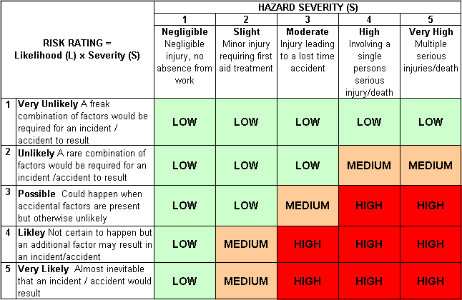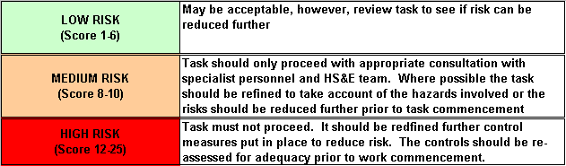Likelihood
How often could the hazard occur? Consider the task, frequency, duration, method of work, employees involved.

Severity

How serious would the hazard’s effects be if
realised? Consider the type of hazard, biological, ergonomic, physical and chemical.

Risk = Likelihood x Severity

E.g. Likelihood (4) X Severity (3) = 12 HIGH RISK

