 |  |  |  |  |  |  |  | Contract Number:
Assessed by: | Name: |  |  | Position: |  |  |  |  | Date:
 | Signed:
Description Of Work: | Transporting no more than 2 cylinders of: Acetylene, LPG, Argon or Oxygen in open vehicles, for use on site.  N.B. This risk assessment assumes the quantities to be transported are below the threshold lints for ADR
Task / Job Component | Hazard |  | Persons at risk |  |  | Risk Rating L/M/H | Controls / Precautions to Reduce Risk |  |  |  | Residual Risk Rating  L/M/H
Transportation | Fire/explosion |  | Drivers, employees, other contractors, public. |  |  | H | - Minimum 2kg dry powder extinguisher to be carried in vehicle.  - No smoking in or near vehicle.  - Cylinders only to be carried in open vehicles.  - Drivers to be trained in use of firefighting appliances and emergency procedures as specified in the Guidance Note 27 BCGA Guidance For The Carriage Of Gas Cylinders On Vehicles.  - Keep cylinders cool (at ambient temperatures). Do not stow gas cylinders in areas where they will be affected by sources of excessive heat. |  |  |  | L
 | Leaks |  | Drivers, employees, other contractors, public. |  |  | H | - Cylinder valves are to be closed whilst in transit. A check should be made to ensure there are no leaks.  - Where supplied, fit suitable protective valve caps and covers to cylinders before transporting.  - Cylinders should not be transported with equipment attached to the valve outlet; disconnect regulators, hoses etc.  - Inspection and test. Gas cylinders are only allowed to be transported if they are in-date for their periodic inspection and test. |  |  |  | L
 | Damage to cylinders |  | Drivers, employees, other contractors, public. |  |  | M | - Cylinders are to be secured so that they cannot move during transport. They shall not project beyond the sides or ends of the vehicle.  - It is recommended that cylinders are transported vertically, secured in an appropriate pallet.  - Other tools and equipment to be stored well away from cylinders. |  |  |  | L
 | Handling of cylinders |  | Drivers, employees, other contractors, public. |  |  | M | - Drivers and operatives to be trained in the manual handling of cylinders.  - Where possible, mechanical offloading should be used. |  |  |  | L
 | Labelling/signage |  | Drivers, employees, other contractors, public. |  |  | M | - Product identification labels are attached to all cylinders. These identify the contents and provide safety advice. The labels are produced in accordance with current legislation, and you must never remove or deface these labels.  - Vehicle hazard labels. If carrying dangerous goods below the threshold level it is not necessary to mark and label your vehicle, but the use of hazard labels can assist the emergency services and they may be displayed. However, all hazard labels have to be removed if you are not carrying dangerous goods. |  |  |  | L
Site-specific Activities | Additional Site–specific Hazards |  | Persons at risk |  |  |  | Additional Controls Required

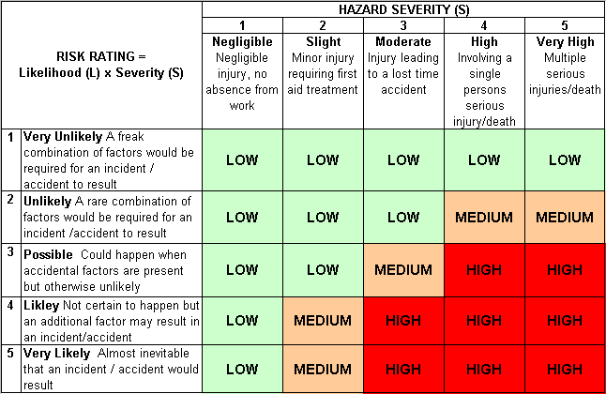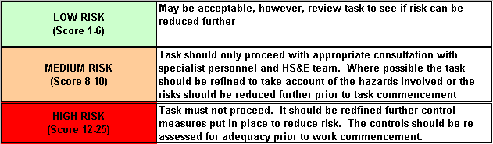Likelihood
How often could the hazard occur? Consider the task, frequency, duration, method of work, employees involved.

Severity

How serious would the hazard’s effects be if
realised? Consider the type of hazard, biological, ergonomic, physical and chemical.

Risk = Likelihood x Severity

E.g. Likelihood (4) X Severity (3) = 12 HIGH RISK

