 |  |  |  |  |  |  |  | Contract Number:
Assessed by: | Name: |  |  | Position: |  |  |  |  | Date:
 | Signed:
Description Of Work:
Task / Job Component | Hazard |  | Persons at risk |  |  | Risk Rating L/M/H | Controls / Precautions to Reduce Risk |  |  |  | Residual Risk Rating  L/M/H
 |  |  |  |  |  |  |  |  |  |  | L
 |  |  |  |  |  |  |  |  |  |  | L
 |  |  |  |  |  |  |  |  |  |  | L
 |  |  |  |  |  |  |  |  |  |  | L
 |  |  |  |  |  |  |  |  |  |  | L
 |  |  |  |  |  |  |  |  |  |  | L
 |  |  |  |  |  |  |  |  |  |  | L
 |  |  |  |  |  |  |  |  |  |  | L
Site-specific Activities | Additional Site–specific Hazards |  | Persons at risk |  |  |  | Additional Controls Required

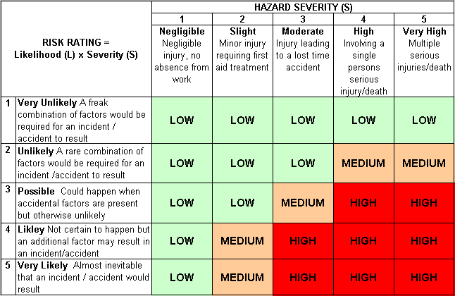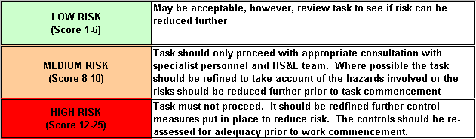Likelihood
How often could the hazard occur? Consider the task, frequency, duration, method of work, employees involved.

Severity

How serious would the hazard’s effects be if
realised? Consider the type of hazard, biological, ergonomic, physical and chemical.

Risk = Likelihood x Severity

E.g. Likelihood (4) X Severity (3) = 12 HIGH RISK

