Site: |  |  |  |  |  |  |  | Contract Number:
Assessed by: | Name: |  |  | Position: |  |  |  |  | Date:
 | Signed:
Description Of Work: | Removal of existing bathroom suites from Social Housing
Task / Job Component | Hazard |  | Persons at risk |  |  | Risk Rating L/M/H | Controls / Precautions to Reduce Risk |  |  |  | Residual Risk Rating  L/M/H
Removal of existing bathroom suites from Social Housing | Contact with human waste/bacteria etc when removing sanitary wares such as toilet seats/baths |  | Operatives, Plumbers |  |  | M | - Ensure impermeable gloves are worn during removal operations.  - Deliver toolbox talk to highlight risks and controls.  - Ensure good personal hygiene i.e. wash hands before eating, drinking or smoking.  - Cover all cuts and grazes with waterproof plasters. |  |  |  | L
 | Needlestick injuries from discarded or hidden syringes (behind bath panels etc) |  | Operatives, Plumbers |  |  | M | - Deliver toolbox talk to highlight risks and controls.  - Ensure suitable disposal methods for sharps i.e. litter picker, sharps box or sharps kits.  - Ensure good personal hygiene i.e. wash hands before eating, drinking or smoking.  - Cover all cuts and grazes with waterproof plasters. |  |  |  | L
Site-specific Activities | Additional Site–specific Hazards |  | Persons at risk |  |  |  | Additional Controls Required

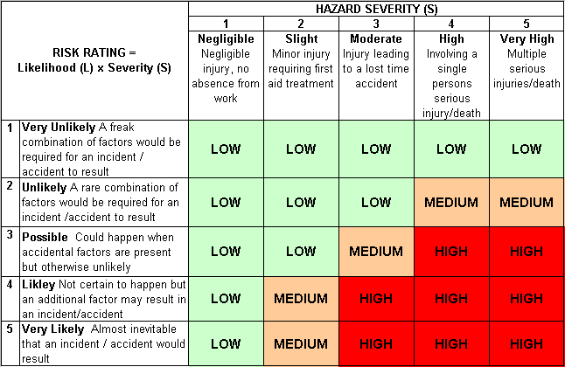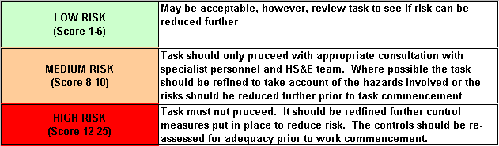Likelihood
How often could the hazard occur? Consider the task, frequency, duration, method of work, employees involved.

Severity

How serious would the hazard’s effects be if
realised? Consider the type of hazard, biological, ergonomic, physical and chemical.

Risk = Likelihood x Severity

E.g. Likelihood (4) X Severity (3) = 12 HIGH RISK

