Site: |  |  |  |  |  |  |  | Contract Number:
Assessed by: | Name: |  |  | Position: |  |  |  |  | Date:
 | Signed:
Description Of Work: | Use of Rhinopatch StreetHeat SR60
Task / Job Component | Hazard |  | Persons at risk |  |  | Risk Rating L/M/H | Controls / Precautions to Reduce Risk |  |  |  | Residual Risk Rating  L/M/H
Operation of Rhinopatch StreetHeat SR60 | Entrapment/entanglement |  | Plant operators |  |  | H | - Ensure all emergency stop buttons are working before use.  - Only competent and trained operators to operate machine.  - Heater Drive Belt - Keep hands and loose clothing clear of drive belt and drive chain.  - Follow manufacturer’s operating instructions. |  |  |  | L
 | Fire/fumes/burns |  | Plant operators, Civils operatives |  |  | H | - Ensure burner controls are functioning correctly prior to use.  - Check all gas hoses and connections for damage prior to use.  - Ensure fire extinguisher is in place before use.  - When gas burners are in operation, ensure machine is in an open and well ventilated area.  - Do not touch hot surfaces or place hands heater panels.  - Heating Zone - The operator must always keep clear and ensure that others are kept clear of the heating zone, as there is a danger of being hit or burnt by the reciprocating heaters.  - Emergency Shutoff - In case of emergency, push the red “Off” button on the top centre of the control panel. This shuts off all electrical systems and propane flow to the heater bed. The pilot lights are not shut off using this button.  - Refer to risk assessment on LPG for propane cylinders.  - Follow manufacturer’s operating instructions. |  |  |  | L
 | Collision with pedestrians/other vehicles |  | Plant operators, Civils operatives, other contractors, visitors |  |  | M | - Only competent and trained operators to operate machine.  - If required, ensure traffic management is in place as per Chapter 8 of New Roads & Streetworks Act.  - Heating Zone - The operator must always keep clear and ensure that others are kept clear of the heating zone, as there is a danger of being hit or burnt by the reciprocating heaters.  - Hand Brake - Always set the hand brake before heating.  - Follow manufacturer’s operating instructions. |  |  |  | L
PPE Requirements | a) Safety glasses to BS EN 166F  b) Gloves to BS EN 388  c) Safety Boots BS EN ISO 20345:2011  d) Ear protection to BS EN 352

Site-specific Activities | Additional Site–specific Hazards | Persons at risk |  | Additional Controls Required

Likelihood
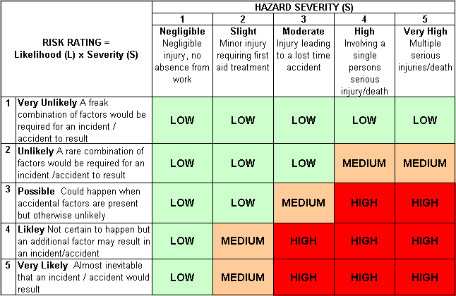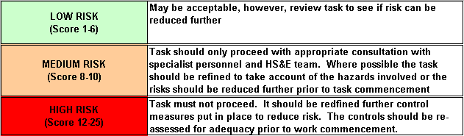How often could the hazard occur? Consider the task, frequency, duration, method of work, employees involved.

Severity

How serious would the hazard’s effects be if
realised? Consider the type of hazard, biological, ergonomic, physical and chemical.

Risk = Likelihood x Severity

E.g. Likelihood (4) X Severity (3) = 12 HIGH RISK

