Site: |  |  |  |  |  |  |  | Contract Number:
Assessed by: | Name: |  |  | Position: |  |  |  |  | Date:
 | Signed:
Description Of Work: | Spray Bodyshop
Task / Job Component | Hazard |  | Persons at risk |  | Risk Rating L/M/H |  | Controls / Precautions to Reduce Risk |  |  |  | Residual Risk Rating  L/M/H
 | Hazardous substances  Contact with body-fillers, glues paint thinners  and paint. |  | Skin contact can lead to workers getting dermatitis. |  | H |  | - Low-protein powder-free latex gloves supplied and used.  - Disposable overalls supplied/used.  - Overalls replaced as required.  - Risk from dermatitis explained to workers, and workers trained to spot (and report) any early signs of dermatitis, ie dry, red, itchy skin.  - Managers to check that gloves are being used.  - As no history of dermatitis at company, occupational health provider (OHP) suggested that annual skin checks sufficient with skin checks on all new employees. |  |  |  | L
 | Inhalation of paint mist containing isocyanate. |  | Workers, and any visitors, breathing in the mist may develop asthma. |  | H |  | - All spraying carried out in spray booth.  - Workers trained in safe use of equipment and safe systems of work.  - Equipment regularly maintained by a competent person and Manger checks this is done and records results.  - Only those with air-fed masks allowed in booth.  - Air-fed masks used by all sprayers and kept in place during ‘clearance time’ (measured at 1min 15secs and marked on outside of booth).  - Spray booth checked to manufacturers instructions and tested and examined every year by insurers.  - Breathing air quality from compressor checked every 3 months by insurers.  - Air-inlet for compressor well clear of any contaminants.  - Sprayguns cleared in ventilated gun cleaner-spray-to-dry in booth wearing air-fed mask.  - Show sprayer’s video clips from HSE MVR website to show how they can be exposed to invisible paint mist.  - Manager check that air-fed masks are used correctly and sprayers don’t flip up visor until after the clearance time.  - Booth automatic over-pressure shut down checked every quarter.  - Biological monitoring (urine tests) and breathing checks (health surveillance) arranged annually for sprayers with occupational health provider to check that controls are worker properly and whether there are early signs of asthma.  - Breathing checks to be carried out on all new employees. |  |  |  | L
 | Inhalation of dust from sanding and grinding operations |  | Sanding/grinding produce large quantities of dust that can damage workers lungs. |  | H |  | - On-tool extraction used for power sanding and grinding.  - Disposable dust masks available for hand sanding  - Arrange examination and testing of extraction equipment every year by insurance company (tie in with booth testing if possible). |  |  |  | L
 | Exposure to UV in UV-cured SMART paint system and arc welding |  | UV can damage unprotected eyes and skin of workers causing ‘arc eye’, cataracts and, long term, skin cancer |  | H |  | - Coverall, gloves and supplied face shield used.  - Training provided by supplier.  - Welding-type screen encloses operation to protect others.  - Explain to sprayers that same precautions taken against inhalation of paint mist as for isocyanates. |  |  |  | L
 | Fire  General |  | Workers/others may suffer serious or fatal injuries from burns and/or smoke inhalation if trapped. |  | H |  | - Fire risk assessments undertaken are required by law.  - Continue to ensure that actions indentified as necessary by the risk assessment are carried out. |  |  |  | L
 | Fuel |  | Workers could suffer severe or fatal burns if petrol gets on them and is ignited |  | H |  | - Fuel tanks reasonably empty (preferably around a quarter full) and fuel cap removed before baking.  - Proprietary fuel-retriever used in open air.  - Hot work on any fuel tank (i.e. including diesel) prohibited unless inerted  - LPG fuelled vehicles subcontracted to specialist refinisher. |  |  |  | L
 | Paint and thinners |  | Paint thinners are highly flammable (as for petrol above) and paint mist can cause fire or explosions |  | H |  | - Less than 50 litres of solvent kept in metal bin inside workshop. Larger quantities kept in locked and ventilated fire-resisting store in the yard.  - Paint mixing unit is fire-resistant and well ventilated.  - All electrical equipment within 1 m of mixer is correctly Ex rated  - Metal bin with tight fitting lid used for waste rags.  - Only Ex rated equipment allowed in spray booth  - No hot work or sparks near fuel or solvent |  |  |  | L
 | Noise |  | Staff and others may suffer hearing damage from exposure to noise from pneumatic tools and metal cutting equipment. E.g. angle grinder |  | H |  | - Purchasing policy to replace tools with quietest option  - Noisy work restricted to ‘ear protection zone’ to reduce the numbers at risk.  - Suitable hearing protectors provided for staff and staff trained how to use, check and maintain them according to advice given by supplier  - Staff trained in risk of noise exposure  - Seek opinion of OHP whether health checks required. |  |  |  | L
 | Vibration |  | Workers may suffer vibration white finger (hand-arm vibration – HAV) from over use of power tools (e.g. sanders, grinders and disc cutters). |  | H |  | - Purchasing policy to have tools that have been designed and constructed to reduce the risk of vibration, and are suitable for their intended use.  - Workers trained to use them safely and keep them properly maintained.  - Seek opinion of OHP whether health checks required. |  |  |  | L
 | Electrical |  | Staff could get electrical shocks or burns from using faulty electrical equipment, or a faulty installation. Electrical faults can also cause fires. |  | H |  | - Low-voltage hand lamps (24 v) used.  - Residual current device (RCD) built into main switchboard.  - Staff trained to spot and report any defective plugs, damaged cables or discoloured sockets to manager.  - Annual testing on all portable 240 v tools.  - Installation regularly maintained to a planned schedule.  - Manager to assess suitability of replacing 240 v tools with air-powered or 110 v alternatives. |  |  |  | L
 | Machinery  E.g. grinding equipment |  | Workers might suffer trap or cut injuries from contact with moving parts, or burn injuries. Also, particles can be ejected into the eyes. |  | H |  | - Pr-use checks on all mechanical equipment, faults reported to manager.  - Equipment not left running unattended.  - Equipment guarded to manufacturers standards  - Safety goggles provided and worn  - Only trained persons use/change grinding wheels |  |  |  | L
 | Failure of car lift or car jack |  | Workers may suffer sever crush injuries if the receiver exploded; or internal damage if compressed air is introduced into the body |  | H |  | - Car lifts/jacks serviced by supplier and examined every 6 months by insurers  - Axle stands maintained and inspected and damaged stands taken out of use  - Axle stands used after lifting vehicle with jack  - Safe working loads not exceeded |  |  |  | L
 | Compressed air  Explosion of equipment, e.g. tyres  Injection of air in the body |  | Staff could suffer blast injuries if the air receiver exploded; or internal damage if compressed air is introduced into the body |  | H |  | - All employees trained in safe working procedures and dangers of horseplay  - Airline has deadman’s handle  - System serviced every year and thoroughly examined by insurers in accordance to the Written Scheme |  |  |  | L
 | Manual handling  In the store; movement of components |  | All employees could suffer from back pain if regularly lifting/carrying heavy or awkward objects. |  | H |  | - Staff instructed to use porters trolley to move heavier materials, parts etc.  - OHP to discuss manual handling techniques with staff. Manager to check the workers know how to lift safely and handle tyres in accordance with Collection and delivery of tyres. |  |  |  | L
 | Handling vehicle air bags |  | Air bags could explode when not fitted, causing injury to workers. |  | H |  | - Units stored in their own, suitable cabinet  - Workers trained in correct handling and fitting  - Faulty units returned to supplier for disposal |  |  |  | L
 | Work involving air conditioning systems |  | Workers might be asphyxiated by gas release in confined space or get frostbite from skin or eye contact with refrigerant. Naked flames can cause refrigerant to decompose, creating harmful gases. |  | H |  | - Workers are trained in correct procedures and certified to EC Minimum Qualifications |  |  |  | L
 | Vehicle movements |  | Workers/others might suffer serious injury, e.g. fractures, if struck by a vehicle (including being struck by a vehicle parked unbraked and/or unchecked and in gear, and then started up from outside the vehicle). |  | H |  | - Safe parking provided for customers  - Marked walkways for pedestrians  - Vehicles driven slowly in/out and around premises  - Parked vehicles are braked or chocked when on vehicle lifts, jacks or axle stands, or slopping ground  - Engines always started and run with brakes on and in neutral gear, and by someone sitting in the drivers seat  - Manager to monitor speed of cars in/out and around premises |  |  |  | L
 | Slip and trips |  | Workers/others may suffer bruising or fractures from slipping on spillages |  | H |  | - Generally good housekeeping standards maintained  - Staff ‘clean as they go’, clear up spillages immediately  - e.g. weekly housekeeping check to be started |  |  |  | L

Site-specific Activities | Additional Site–specific Hazards | Persons at risk |  | Additional Controls Required
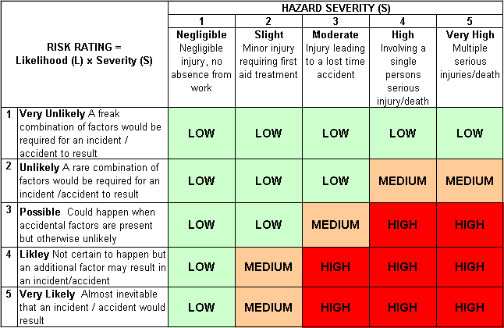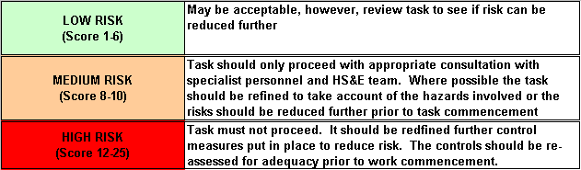Likelihood
How often could the hazard occur? Consider the task, frequency, duration, method of work, employees involved.

Severity

How serious would the hazard’s effects be if
realised? Consider the type of hazard, biological, ergonomic, physical and chemical.

Risk = Likelihood x Severity

E.g. Likelihood (4) X Severity (3) = 12 HIGH RISK

