NORTHERN COUNTIES SAFETY GROUP LIMITED
Safety Training & Services to the Construction Industry
Safe Use of Vertical Spindle Moulder

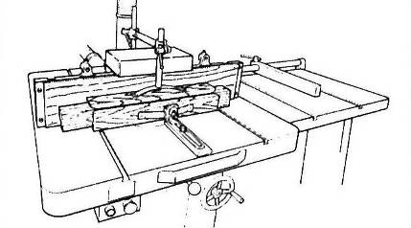

Only trained and authorised employees to use this machine, as per ACOP L114

Safe Use Procedures

- Use table rings to close the gap between the table and spindle
- Only use if trained and authorised
- Use a false fence for ALL types of straight work
- For continuous length straight work, use a demountable power feed unit
- For curved work, use a properly constructed jig or work holder together with a ring guide and adjustable guard
- Where appropriate use a push block or push stick
- For stopped work, fit front and back stops and use a suitable work holder
- Only use limited cutter projection tooling (as required by PUWER 98)
- Check the selected spindle speed does not exceed the maximum speed marked on the tool
- Fit and properly adjust all guards and safety devices before starting the machine – report any defects immediately to your supervisor
- Do not leave the machine unattended whilst the cutter is rotating
- Always use the braking device to stop the machine/cutter
- Ensure the working area is well illuminated and is kept clean, clear and tidy.
- No loose clothing due to entanglement risk.
- Use all Personal Protective Equipment (PPE) provided by your employer (e.g. hearing defenders, respirators etc)

Machine Maintenance and Cleaning

- Do not remove off-cuts, clean the machine or adjust guards whilst the auger/chisel is in motion

- Maintain the machine in accordance with the manufacturer’s instructions

