Site: | Text in italics to be replaced with specific site information. State site address here. |  |  |  |  |  |  | Contract Number:
Assessed by: | Name: |  |  | Position: |  |  |  |  | Date:
 | Signed:
Description Of Work: | Describe the activity that exposes the operatives to the vibration hazard (example cutting penetrations in roof cladding panels for roof lights using a reciprocating saw. 6 no roof lights in total) or (compacting stone using a vibrating plate)
Task / Job Component | Hazard |  | Persons at risk |  |  | Risk Rating L/M/H | Supporting Information used in Assessing the Risk |  |  |  | Residual Risk Rating  L/M/H
Example cutting penetrations using reciprocating saw or using vibrating plate. | Hand Arm Vibration |  | Operators of the equipment |  |  | H | What equipment will be used that exposes the operatives to the vibration?  Stipulate Equipment: example reciprocating saw or vibrating plate.
 |  |  |  |  |  | H | What is the magnitude of the vibration?  The manufactures of the equipment will provide you with information on the magnitude of exposure; this will be expressed in metres per second squared m/s2.
 |  |  |  |  |  | H | Have specific measurements been taken on your vibration activity?  A competent person can assess specific vibration levels. If this has taken place, state results here. If not then use manufacturers exposure level.
 |  |  |  |  |  | H | How many hours will the activity take per day (normally in an 8 hour shift?)  Stipulate the length of time the operation will take in hours and minutes

Stipulate the exposure normalised over an 8 hour shift?

This will be expressed as m/s2 A(8) this means the exposure level based on an 8 hour shift. To identify this number you should use the HSE’s HAV Calculator which is available on www.hse.gov.uk and type in the search box HAV Calculator.

If the exposure level is below the daily action value of 2.5m/s2 then you should reduce the exposure to as low as practicable and continue with the works.

If the exposure is above 2.5m/s2 then try and eliminate or control the exposure. (see control measures)

If the exposure level is above 5m/s2 then immediately contact your safety advisor at NCSG and ask for specific advice. Do not continue with the work. The vibration exposure risks are high.

Site-specific Activities | Hazards |  | Persons at risk |  |  |  | Control Measures
Example cutting penetrations using reciprocating saw or using vibrating plate. | Hand Arm Vibration |  | Operators of the equipment |  |  | H | If possible ELIMINATE vibration from the process. Example of elimination would include factory manufacture as opposed to cutting on site, using remote controlled tools such remote roller etc.
Site-specific Activities | Hazards |  | Persons at risk |  |  |  | Control Measures
Example cutting penetrations using a reciprocating saw or using a vibrating plate | Hand Arm Vibration |  | Operators of the equipment |  |  | H | Select equipment for reduced vibration exposure.  When purchasing or hiring specify that the equipment has anti-vibration controls added and reduces the vibration exposure to the lowest level possible.  Also consider tool weight, handles for additional comfort and state any ergonomic factors that are incorporated into the tool to improve posture.  State tool anti-vibration controls here.

Maintenance of tools and equipment.

Equipment should be serviced and maintained. Specify here specific measures that will be adopted.

- Cutting tools will be sharp
- Grinding wheels will be correctly fitted to minimise oscillation.
- Worn parts will be immediately replaced
- New blades will be purchased and changed if they become blunt.

Reduce the period of exposure.

Job rotation (sharing the work and vibration exposure between several people)

Stagger work activities (breaks) to ensure that workers undertake non vibration exposure activities following vibration exposure.
Site-specific Activities | Hazards |  | Persons at risk |  |  |  | Control Measures
Example cutting penetrations using a reciprocating saw or using a vibrating plate | Hand Arm Vibration |  | Operators of the equipment |  |  | H | Information and training for workers and supervisors  - Workers will be involved when deciding on the control measures.  - Workers will be informed of the vibration exposure and exposure time limits.  - Workers will be informed on the importance of maintaining blood circulation, keeping warm.  - Wet gloves must be removed and the welfare facilities will be warm and dry  - Secure the work pieces were practicable to prevent item vibrating.
 |  |  |  |  |  | H | Health Surveillance  Health surveillance is a programme of health checks to identify early signs and symptoms of hand arm vibration syndrome.  If the exposure is above the daily action value of 2.5m/s2 then health surveillance is required. Contact your NCSG advisor to discuss.  Health surveillance is not appropriate for individuals whose daily exposures exceed the exposure action value only on rare occasions and the risk assessment identifies the risk of ill health to be very low.
 | Additional Hazards |  | Persons at risk |  |  |  | Additional Control Measures

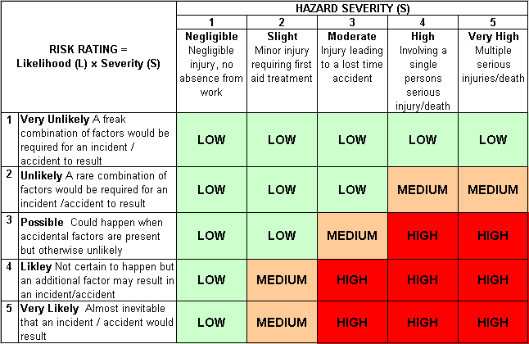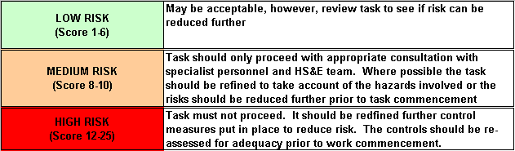Likelihood
How often could the hazard occur? Consider the task, frequency, duration, method of work, employees involved.

Severity

How serious would the hazard’s effects be if
realised? Consider the type of hazard, biological, ergonomic, physical and chemical.

Risk = Likelihood x Severity

E.g. Likelihood (4) X Severity (3) = 12 HIGH RISK

