Site: |  |  |  |  |  |  |  | Contract Number:
Assessed by: | Name: |  |  | Position: |  |  |  |  | Date:
 | Signed:
Description of Work: | Use of Warehouse Step Ladders
Task / Job Component | Hazard |  | Persons at risk |  |  | Risk Rating L/M/H | Controls / Precautions to Reduce Risk |  |  |  | Residual Risk Rating  L/M/H
Use of Warehouse Step Ladders | Falling from height |  | Operative, 3rd parties |  |  | H | - Work should be of short duration (e.g. 30 minutes)  - Work should not involve over reaching.  - Ground conditions must be flat, level and stable.  - Operative trained in use of step ladders and ladder used in accordance with training methods  - Step Ladder in good order, visually inspected before use, with current inspection status (normally 6 monthly thorough inspection tag displayed)  - Only simple work of short time duration should be carried out from a step ladder.  - Extra care should be taken when using warehouse step ladders in occupied areas  - Only Class 1 Industrial or BS EN 131 step ladders to be used. |  |  |  | L
 | Items falling from height |  | Operative, 3rd parties |  |  | H | - Minimise materials stored and ensure SWL is not exceed  - Ensure other staff and public are kept out of the area. |  |  |  | L
 | Slips/trips/falls |  | Operative, 3rd parties |  |  | M | - Check route before moving step ladder and ensure clear walkway  - Ensure stable and level ground. |  |  |  | L
Site-specific Activities | Additional Site–specific Hazards |  | Persons at risk |  |  |  | Additional Controls Required

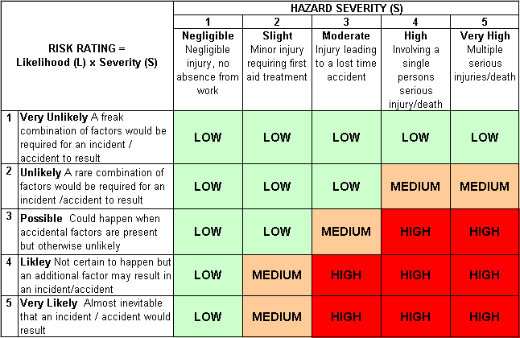
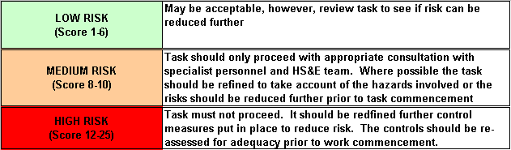
Likelihood
How often could the hazard occur? Consider the task, frequency, duration, method of work, employees involved.

Severity

How serious would the hazard’s effects be if
realised? Consider the type of hazard, biological, ergonomic, physical and chemical.

Risk = Likelihood x Severity

E.g. Likelihood (4) X Severity (3) = 12 HIGH RISK

