Site: |  |  |  |  |  |  |  | Contract Number:
Assessed by: | Name: |  |  | Position: |  |  |  |  | Date:
 | Signed:
Description Of Work: | Work at height on plant
Task / Job Component | Hazard |  | Persons at risk |  |  | Risk Rating L/M/H | Controls / Precautions to Reduce Risk |  |  |  | Residual Risk Rating  L/M/H
Operating and maintaining items of construction plant | Falls from plant |  | Plant Operators, Plant Mechanics |  |  | H | Where possible avoid working from height and carry out repairs/inspections from ground level.  - Always ascend and descend from machines facing forwards and using the correct handles and steps.  - Ensure guard rails are fitted on walkways and around engine access hatches where required, prior to undertaking maintenance work or repairs.  - Use soft landing systems where integrated guardrails are not in place |  |  |  | L
Site-specific Activities | Additional Site–specific Hazards |  | Persons at risk |  |  |  | Additional Controls Required

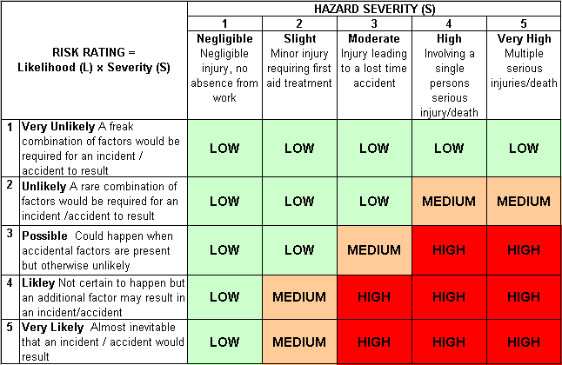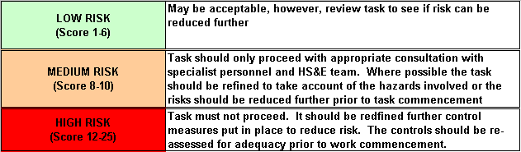Likelihood
How often could the hazard occur? Consider the task, frequency, duration, method of work, employees involved.

Severity

How serious would the hazard’s effects be if
realised? Consider the type of hazard, biological, ergonomic, physical and chemical.

Risk = Likelihood x Severity

E.g. Likelihood (4) X Severity (3) = 12 HIGH RISK

