Site: |  |  |  |  |  |  |  | Contract Number:
Assessed by: | Name: |  |  | Position: |  |  |  |  | Date:
 | Signed:
Description Of Work: | Use of working platform attached to telehandler.
Task / Job Component | Hazard |  | Persons at risk |  |  | Risk Rating L/M/H | Controls / Precautions to Reduce Risk |  |  |  | Residual Risk Rating  L/M/H
General use | Stability of telehandler & platform |  | Operatives on platform/telehandler operator/other contractors nearby |  |  | H | - Ensure the ground is capable of supporting the weight of the telehandler, platform and load.  - Only use on firm, level ground, away from excavations.  - Ensure total weight of platform and load does not exceed the Safe Working Load of the telehandler.  - Ensure outriggers/stabilisers are deployed prior to lift.  - Ensure handbrake is applied prior to lifting.  - Check tyre pressures prior to use.  - Only trained and competent persons to operate telehandler. |  |  |  | L
 | Platform becoming detached from forks |  | Operatives on platform/telehandler operator/other contractors nearby |  |  | H | - Follow manufacturer’s instructions for fitting of platform to forks.  - Ensure all locking devices are in place to prevent platform from sliding off forks.  - Ensure tilt and side-shift controls are isolated prior to lift.  - Telehandler must not be moved with persons on the platform. It must only be raised/lowered.  - Operator must remain at the controls at all times when the platform is in an elevated position. |  |  |  | L
 | Falls from platform |  | Operatives on platform |  |  | H | - Check 6 month certificate of thorough examination for platform.  - Operatives to be secured to anchor point in platform (tested to BSEN795) using full body harness and restraint lanyard.  - All operatives wearing harnesses must have received training in harness use and user inspections.  - Operatives must not lean out of platform or stand on guardrails/toeboards. |  |  |  | L
General use | Falls of materials/equipment from platform |  | Other contractors nearby |  |  | M | - Ensure platform is fitted with suitable guardrails and toeboards that comply with the Work at Height Regulations 2005.  - Set up an exclusion zone around working area with signage and barriers. |  |  |  | L
 | Entrapment in telehandler mechanism when on platform |  | Operatives on platform |  |  | M | - Ensure platform is fitted with suitable guardrails and toeboards that comply with the Work at Height Regulations 2005.  - Set up an exclusion zone around working area with signage and barriers. |  |  |  | L
 | Contact with overhead cables/ structures |  | Operatives on platform |  |  | H | - Survey area prior to lifting and isolate any live electric cables.  - 2-way radios to be used to communicate between telehandler operator and operatives on platform. |  |  |  | L
Site-specific Activities | Additional Site–specific Hazards |  | Persons at risk |  |  |  | Additional Controls Required

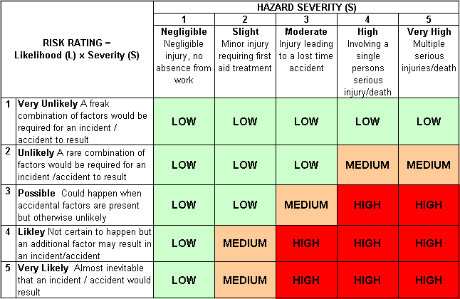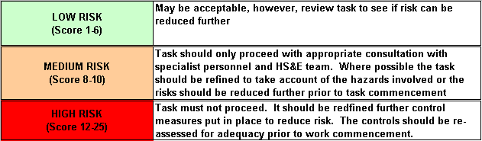Likelihood
How often could the hazard occur? Consider the task, frequency, duration, method of work, employees involved.

Severity

How serious would the hazard’s effects be if
realised? Consider the type of hazard, biological, ergonomic, physical and chemical.

Risk = Likelihood x Severity

E.g. Likelihood (4) X Severity (3) = 12 HIGH RISK

