 |  |  |  |  |  |  |  | Contract Number:
Assessed by: | Name: |  |  | Position: |  |  |  |  | Date:
 | Signed:
Description Of Work: | Working Outdoors in Hot Weather
Task / Job Component | Hazard |  | Persons at risk |  |  | Risk Rating L/M/H | Controls / Precautions to Reduce Risk |  |  |  | Residual Risk Rating  L/M/H
Working Outdoors | Heat Stroke/Heat Stress |  | All Operatives/Visitors |  |  | H | - Schedule heavy duty works to be carried out at the coolest part of the day i.e. early morning/late afternoon  - Use engineering controls fans/cooling systems  - Provide suitable shaded rest areas with adequate ventilation  - Implement a permit system identifying safe working times  - Encourage and monitor regular rest breaks  - Provide cool drinking water stations  - Encourage workers to drink plenty water to replace lost fluids during sweating  - Monitor dehydration levels through urine colour sample charts  - Toolbox talks on heat stress related symptoms  - Ensure persons are fit for work and don’t have any medical conditions that could be made worse  - Encourage workers to wear loose light clothing  - Avoid hot works during the hottest parts of the day  - Provide cooling liner equipment for hard hats  - Provide adequate supervision to monitor workers conditions and heat. |  |  |  | L
 | Sunburn/Skin Cancer |  | All Operatives/Visitors |  |  | H | - Provide suitable sunscreen on site 30+ factor  - Encourage workers to wear and reapply sunscreen frequently  - Skin to be kept covered with breathable loose-fitting clothing (No removing t-shirts)  - Encourage workers to regularly check their skin for unusual spots/moles  - Provide training/information on sun protection and skin cancer risks |  |  |  | L

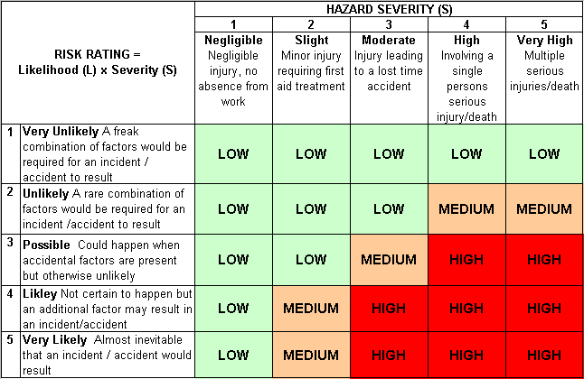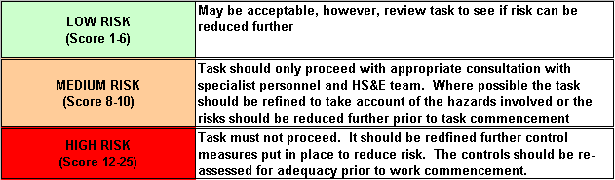Likelihood
How often could the hazard occur? Consider the task, frequency, duration, method of work, employees involved.

Severity

How serious would the hazard’s effects be if
realised? Consider the type of hazard, biological, ergonomic, physical and chemical.

Risk = Likelihood x Severity

E.g. Likelihood (4) X Severity (3) = 12 HIGH RISK

