Site: |  |  |  |  |  |  |  | Contract Number:
Assessed by: | Name: |  |  | Position: |  |  |  |  | Date:
 | Signed:
Description Of Work: | Felling or pruning trees – not circular saw work.
Task / Job Component | Hazard |  | Persons at risk |  |  | Risk Rating L/M/H | Controls / Precautions to Reduce Risk |  |  |  | Residual Risk Rating  L/M/H
Treework. | Fire. |  | Tree surgeons, other workers, members of the public. |  |  | H | Prohibit burning.  - Burning manned until extinguished.  - Designated area for burning and approval from the Environment Agency (EA).  - Refill fuel tanks 4m away from sources of ignition.  - Use explosion-proof and spill-proof fuel cans.  - Fuel separated from cab area by solid bulkhead, well ventilated or in open back of vehicle.  - No smoking rule. |  |  |  | L
 | Accidents requiring first aid. |  | Tree surgeons, other workers, members of the public. |  |  | H | Ensure there are trained first-aiders and a first-aid kit on site.  Access to a telephone / mobile  Means of rescue of injured person |  |  |  | L
 | Electrocution. |  | Tree surgeons, other workers, members of the public. |  |  | H | Survey for overhead power lines and precautions in accordance with GS6. |  |  |  | L
 | Vibration. |  | Tree surgeons, other workers, members of the public. |  |  | H | Wearing of gloves where possible, or other means to keep hands warm.  - Rotation of the work.  - Frequent maintenance of the saws.  - Purchase of saws with the lowest vibration. |  |  |  | L
 | Noise. |  | Tree surgeons, other workers, members of the public. |  |  | H | Wearing of ear defenders.  - Frequent sharpening of tools. |  |  |  | L
 | Fall of material/tools. |  | Tree surgeons, other workers, members of the public. |  |  | H | A manned Dropping Zone agreed for each operation.  - Tools raised by line. |  |  |  | L
 | Fall from height. |  | Tree surgeons, other workers, members of the public. |  |  | H | Safety harnesses and safety rope system with a daily inspection regime.  - Qualified users only.  - Free climbing prohibited.  - Use of MEWP wherever reasonable and if tree is decayed.  - Use of pole pruners for low level branches.  - Use of ladders should be avoided. |  |  |  | L
 | Structural failure of access equipment. |  | Tree surgeons, other workers, members of the public. |  |  | H | Regular inspection.  - Clear marking of safe working load and number of persons the equipment is capable of carrying safely.  - User inspection.  - Prohibit any adaptation or alternative use for lifting materials. |  |  |  | L
 | Unauthorised access. |  | Tree surgeons, other workers, members of the public. |  |  | H | Isolate/immobilise powered access equipment when not in use.  - Remove all other equipment when not supervising work area.  - Erect barriers or rope and signs around the dropping zone.  - Stable stacking.  - Use of stop/go signs.  - Other workers to be made aware of tree operations. |  |  |  | L
 | Manual handling. |  | Tree surgeons, other workers, members of the public. |  |  | H | Training.  - Use of mechanical handling equipment.  - Appropriate use of breaker bar, log tongs and high lift wedges (or felling cushions). |  |  |  | L
 | Weather. |  | Tree surgeons, other workers, members of the public. |  |  | H | Suspend work during strong winds, poor visibility or icy conditions. |  |  |  | L
 | Damage to underground services. |  | Tree surgeons, other workers, members of the public. |  |  | H | Study utility plans and check with a cable avoiding tool (CAT).  Protect services with heavy duty road plates, bog mats or avoid drops. |  |  |  | L
 | Use of chippers. |  | Tree surgeons, other workers, members of the public. |  |  | H | Training.  - Guard and protection device fitted, checked and maintained regularly.  - No loose clothing, eye and hearing protection worn.  - Push stick for short material. |  |  |  | L
 | Vehicle movements. |  | Tree surgeons, other workers, members of the public. |  |  | H | Signage in accordance with Chapter 8 of the Traffic Signs Manual.  - Use of a Banksman for all reversing.  - CCTV on vehicles.  - Wearing of high-visibility clothing. |  |  |  | L
 | Injury from chainsaws. |  | Tree surgeons, other workers, members of the public. |  |  | H | Maintenance and inspection regime for all saws.  - Only operators who have been trained on the specific type of saw.  - Saw chain brake and inertia test before use.  - Operator procedure for repair.  - Wearing of protective clothing and footwear.  - Members of the public and other workers prohibited from collecting from site.  - Personal first-aid kit. |  |  |  | L
 | Slips and trips. |  | Tree surgeons, other workers, members of the public. |  |  | H | Safety footwear.  - Continual tidy working methods. |  |  |  | L
Site-specific Activities | Additional Site–specific Hazards |  | Persons at risk |  |  |  | Additional Controls Required

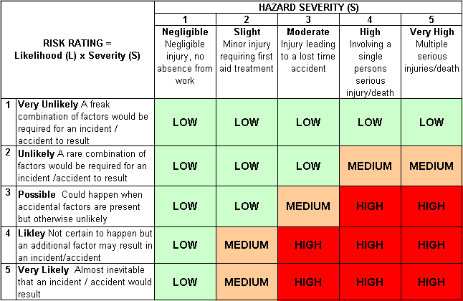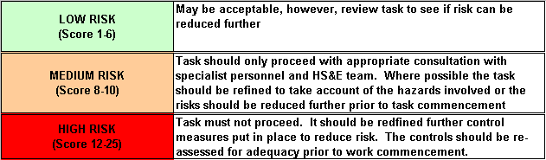Likelihood
How often could the hazard occur? Consider the task, frequency, duration, method of work, employees involved.

Severity

How serious would the hazard’s effects be if
realised? Consider the type of hazard, biological, ergonomic, physical and chemical.

Risk = Likelihood x Severity

E.g. Likelihood (4) X Severity (3) = 12 HIGH RISK

