COVID 19 OFFICE CLEANING CHECKLIST
These procedures are to be followed by Cleaners carrying out regular office cleaning.
Wear disposable gloves and use normal household disinfectant cleaner (Dettox sprays or similar).
- Wash your hands with warm soap and water for at least 20 seconds. If there is no water available use minimum 60% alcohol hand sanitiser.
- Make sure you wear disposable gloves. Guidance on how to remove them is on the rear of this checklist.
- Carry out general cleaning as usual e.g. vacuuming carpets, mopping hard floors etc.
- Concentrate on “touch points” areas that are touched by lots of people such as:
    - Door Handles (internal and external).
    - Telephones and intercom systems.
    - Photocopier buttons/keyboards.
    - Bathroom taps and toilet flush handles.
    - Kettles, dishwasher handles, fridge door handles etc
    - Desk surfaces including drawer handles.
    - Keyboards and mice.
- Office employees will be encouraged to keep desks free from clutter and paperwork to allow full desktops to be accessible for cleaning.
- Once completed. Remove gloves as per instructions overleaf. Dispose of gloves and any used wipes in plastic bags and then place in general waste bins.
- Now wash your hands with warm soap and water for at least 20 seconds. If there is no water available use minimum 60% alcohol hand sanitiser.

N.B. Any areas that require a deep clean and disinfecting after an employee has been confirmed with Covid19 will be cleaned by a specialist cleaning company.

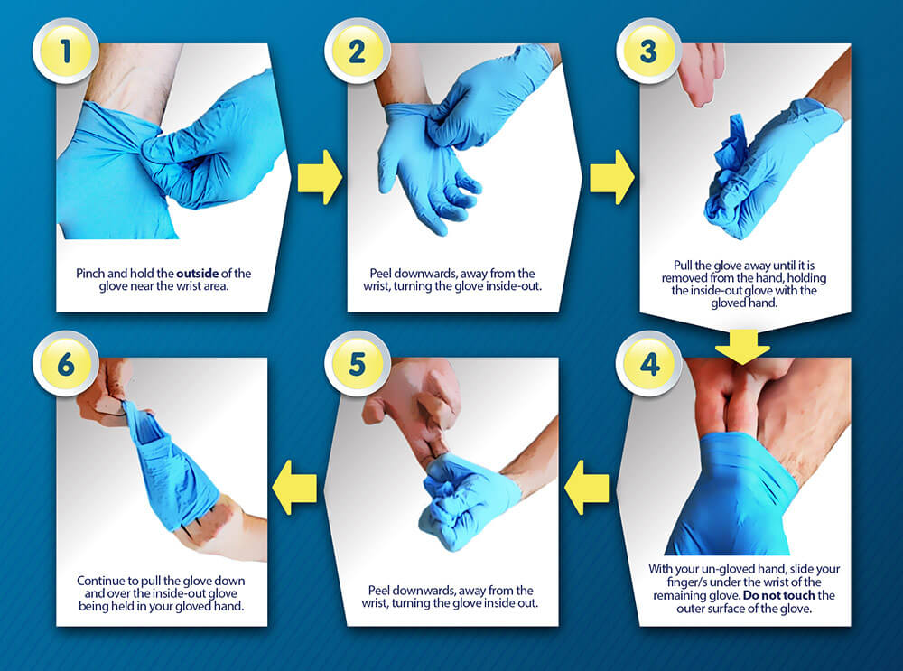
HOW TO REMOVE GLOVES SAFELY

