Company Name:  Site: |  |  | COSHH  Assessment
Supplier: |  |  | COSHH Number | 10
 |  |  |  | page 1
Assessment By: | Activity: |  | Review Date | Assessment Date
 | Office cleaning
 | Persons/Groups at Risk

NAME OF HAZARDOUS SUBSTANCE USED OR CREATED
Substance: Cif Cream

 | 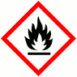 |  |  | 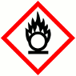 |  |  | 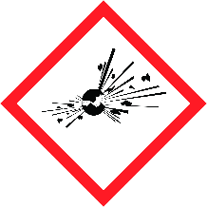 |  |  |  |  |  |  |  |  | 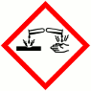
 | FLAMMABLE |  |  | OXIDISING |  |  | EXPLOSIVE |  |  | IRRITANT |  |  | HARMFUL |  |  | CORROSIVE
 | YES | NO |  | YES | NO |  | YES | NO |  | YES | NO |  | YES | NO |  | YES | NO
 | Insert in appropriate boxes
 | 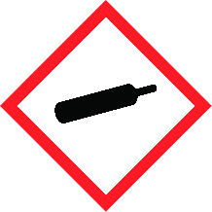 |  |  | 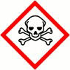 |  |  | 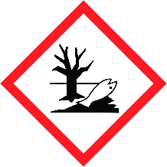
 | COMPRESSED GAS |  |  | TOXIC |  |  | HARMFUL TO THE EINVIRONMENT
 | YES | NO |  | YES | NO |  | YES | NO |  | YES | NO |  | YES | NO |  | YES | NO

Insert in appropriate boxes

Please add comments into boxes where required. |  | Insert in appropriate boxes |  | YES | NO
Is Manufacturers Safety Data Sheet available?
Does the Substance have a Workplace Exposure Limit (WEL)?
If the substance has a WEL please state. if un-sure check HSE document – EH40
Can a safer substance be used or can the substance be enclosed or extracted.
Will employees be given information and training?
Will Personal Protective Equipment be provided for employees?
State the standard of RPE (respirators)
State the standard of Goggles or Spectacles
State the standard of Gloves
State the standard of Overalls
State the standard of Boots
Other Equipment |  |  | Attach details if YES
Will Exposure Monitoring and/or Control Measures be required? |  |  | Attach details if YES
Will Health Surveillance be necessary? |  |  | Attach details if YES
Does this Substance need to be disposed of by a Waste Disposal Contractor?
Have all necessary First-aid requirements been provided?
Have Storage requirements for the substance been provided/arranged on site?
FIRST AID, FIRE FIGHTING, STORAGE & HANDLING, DISPOSAL AND ACCIDENTAL RELEASE INSTRUCTIONS ARE PROVIDED ON PAGES 2 & 3 |  |  | Number of Sheets attached to this Assessment

FIRST AID INSTRUCTIONS
Route of Exposure, or  Type of Injury | First Aid Treatment
Skin Contact | Wash thoroughly.
Eye Contact | Rinse immediately with plenty of water, holding the eyelids open and seek medical advice if effects persist.
Inhalation | Remove from source of exposure.
Ingestion | Remove product from mouth, give the casualty a small quantity of water to drink and seek medical advice. Do not induce vomiting.
General Information | N/A

FIRE FIGHTING MEASURES
Hazard | Measures
Fire | NON FLAMMABLE - In the event of a fire due to other causes the product is compatible with water, foam, carbon dioxide and dry powder  extinguishers. May evolve toxic fumes if involved in a fire. Fire-fighters should wear self contained breathing apparatus.
Stability | Provided the product is stored in accordance with the approved guidelines there are no known hazardous decomposition products.
Decomposition Products | Provided the product is stored in accordance with the approved guidelines there are no known hazardous decomposition products.

MANUFACTURERS INFORMATION
Manufacturers Name and Address | JohnsonDiversey UK Limited  Weston Favell Centre Northampton NN3 8PD
Manufacturers Health & Safety Data Sheet Reference | 660183
24 Hour Emergency Telephone Number | 0800 052 0185
Regulatory Information: Warning Label Phrases | H319 Irritating to eyes.  EUH208 May produce an allergic reaction  P101 - If medical advice is needed, have product container or label at hand.  P102 - Keep out of reach of children.

STORAGE AND HANDLING
Hazard | Measures
Handling | Avoid contact with skin and eyes. Rinse and dry hands after use, for prolonged contact protection of the hands may be necessary. Do not mix with any other chemicals other than as advised by your JohnsonDiversey representative.
Storage | Store upright in original closed containers in a cool place.

DISPOSAL MEASURES
Hazard | Measures
Pollution of water courses or drains | This product does not contain any prescribed substance under the Environmental Protection Act (Prescribed Processes and Substances)  Regulations 1991 and is not classified as special waste under the Control of Substances (Special Waste) Regulations 1996, but is classified  as controlled waste under the Environmental Protection Act 1990. For small quantities, dilute with water to at least 5% w/v (50 g/litre) and  pour down a wastewater drain (foul sewer). Rinse out containers at least twice and recycle if facilities exist or dispose of as commercial  waste. For larger quantities dispose of safely as commercial waste.  European waste catalogue 20 01 29 Detergents containing dangerous substances

ACCIDENTAL RELEASE MEASURES
Hazard | Measures
Spillage | Hose away with plenty of water diluting to at least 5% w/v (50 g/litre) unless this would contaminate a water course or vegetation, in which  case either collect, dilute as earlier and pour down wastewater drain (foul sewer) or absorb onto dry sand or similar material and dispose of  safely as commercial waste.

USAGE/EXPOSURE
Frequency and Duration of use
Maximum number of people involved in activity
Quantities stored/used
Exposure levels

Safe System of Work

1. Ensure cleaners wear rubber gloves when using these products.

2. Ensure these products are stored in the cleaning cupboards, which are to be kept locked at all times.

3.

4.

5.

6.

7.

8.

9.

10.

Operatives Acknowledgement

Name: | Signature: | Date: | Name: | Signature: | Date:

