Company Name:  Site: |  |  |  | COSHH  Assessment
Supplier: |  |  |  | COSHH Number | 15
 |  |  |  |  | page 1
Assessment By: |  | Activity: |  | Review Date | Assessment Date
 |  | Fitting Rockwool insulation to brickwork
 |  | Persons/Groups at Risk
 |  | Rockwool Insulation
 | NAME OF HAZARDOUS SUBSTANCE USED OR CREATED
 | Substance:

 | 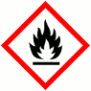 |  |  | 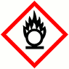 |  |  | 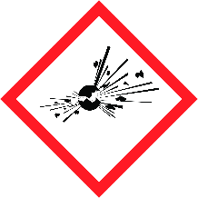
 | FLAMMABLE |  |  | OXIDISING |  |  | EXPLOSIVE |  |  | IRRITANT |  |  | HARMFUL |  |  | CORROSIVE
 | YES | NO |  | YES | NO |  | YES | NO |  | YES | NO |  | YES | NO |  | YES | NO
 | Insert in appropriate boxes
 | 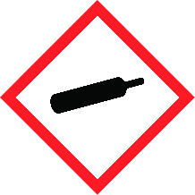 |  |  | 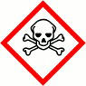 |  |  | 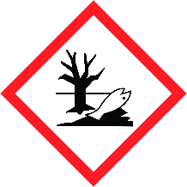
 | COMPRESSED GAS |  |  | TOXIC |  |  | HARMFUL TO THE EINVIRONMENT
 | YES | NO |  | YES | NO |  | YES | NO |  | YES | NO |  | YES | NO |  | YES | NO

Insert in appropriate boxes

Please add comments into boxes where required. |  | Insert in appropriate boxes |  | YES | NO
Is Manufacturers Safety Data Sheet available?
Does the Substance have a Workplace Exposure Limit (WEL)?
If the substance has a WEL please state. if un-sure check HSE document – EH40 |  |  | Refer to SDS
Can a safer substance be used or can the substance be enclosed or extracted.
Will employees be given information and training?
Will Personal Protective Equipment be provided for employees?
State the standard of RPE (respirators) |  |  | FFP2
State the standard of Goggles or Spectacles |  |  | BS EN 166 glasses
State the standard of Gloves
State the standard of Overalls
State the standard of Boots |  |  | BE EN 345
Other Equipment |  |  | Attach details if YES
Will Exposure Monitoring and/or Control Measures be required? |  |  | Attach details if YES
Will Health Surveillance be necessary? |  |  | Attach details if YES
Does this Substance need to be disposed of by a Waste Disposal Contractor?
Have all necessary First-aid requirements been provided?
Have Storage requirements for the substance been provided/arranged on site?
FIRST AID, FIRE FIGHTING, STORAGE & HANDLING, DISPOSAL AND ACCIDENTAL RELEASE INSTRUCTIONS ARE PROVIDED ON PAGES 2 & 3 |  |  | Number of Sheets attached to this Assessment

FIRST AID INSTRUCTIONS
Route of Exposure, or  Type of Injury | First Aid Treatment
Skin Contact | If irritation occurs, wash off dust under running water prior to washing with soap and water.  Advise not to rub or scratch affected area.
Eye Contact | Irrigate eyes with clean water - Do not rub eyes. Seek medical attention if symptoms persist.
Inhalation | If throat irritation occurs rinse with drinking water. If symptoms persist seek medical advice.
Ingestion | Not applicable.
General Information | n/a

FIRE FIGHTING MEASURES
Hazard | Measures
Fire | The products are non-combustible and do not pose a fire hazard. Punking may occur at high temperatures. Some facings and packaging materials may burn.
Stability | Stable and non-reactive
Decomposition Products | When insulation wool is heated to approximately 200°C for the first time(s) binder components and decomposition gases are emitted from the binder. The decomposition starts at approximately 200°C and the duration of release depends on thickness of insulation, binder content and temperature(s) applied.

MANUFACTURERS INFORMATION
Manufacturers Name and Address | ROCKWOOL Limited  Pencoed  Bridgend  CF35 6NY
Manufacturers Health & Safety Data Sheet Reference | N/A
24 Hour Emergency Telephone Number | 01656 862 621
Regulatory Information: Warning Label Phrases | None

STORAGE AND HANDLING
Hazard | Measures
Handling | Unpack material at application site to avoid unnecessary handling of product. Keep work areas clean. Dispose of scrap material and debris in suitable containers. Spray with water before sweeping or use vacuum equipment.
Storage | Keep material in original packaging until it is to be used. Store material to protect against damage including the weather

DISPOSAL MEASURES
Hazard | Measures
Pollution of water courses or drains | Hazardous waste regulations; ROCKWOOL insulation is classified as non-hazardous waste. ROCKWOOL insulation waste is covered by the non-hazardous entry "17 06 04 insulation materials other than those mentioned in 17 06 01 and 17 06 03" in the List of Wastes/the European Waste Catalogue (EWC).

ACCIDENTAL RELEASE MEASURES
Hazard | Measures
Spillage | No special measures required

USAGE/EXPOSURE
Frequency and Duration of use
Maximum number of people involved in activity
Quantities stored/used
Exposure levels

Safe System of Work

1.

2.

3.

4.

5.

Operatives Acknowledgement

Name: | Signature: | Date: | Name: | Signature: | Date:

