Company Name:  Site: |  |  | COSHH  Assessment
Supplier: | N/A |  | COSHH Number | 20
 |  |  |  | page 1
Assessment By: | Activity: |  | Review Date | Assessment Date
 | Grinding out old cement mortar joints in brickwork
 | Persons/Groups at Risk
 | Operatives

NAME OF HAZARDOUS SUBSTANCE USED OR CREATED
Substance: Respirable Crystalline Silica

 |  |  |  |  |  |  | 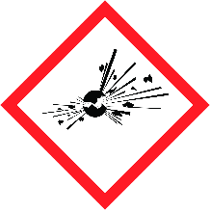 |  |  |  |  |  |  |  |  | 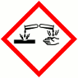
 | FLAMMABLE |  |  | OXIDISING |  |  | EXPLOSIVE |  |  | IRRITANT |  |  | HARMFUL |  |  | CORROSIVE
 | YES | NO |  | YES | NO |  | YES | NO |  | YES | NO |  | YES | NO |  | YES | NO
 | Insert in appropriate boxes
 | 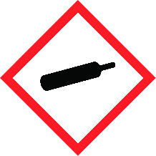 |  |  |  |  |  | 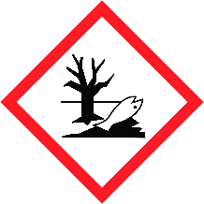
 | COMPRESSED GAS |  |  | TOXIC |  |  | HARMFUL TO THE EINVIRONMENT
 | YES | NO |  | YES | NO |  | YES | NO |  | YES | NO |  | YES | NO |  | YES | NO

Insert in appropriate boxes

Please add comments into boxes where required. |  | Insert in appropriate boxes and add comment below |  | YES | NO
Is Manufacturers Safety Data Sheet available?
Does the Substance have a Workplace Exposure Limit (WEL)?
If the substance has a WEL please state. if un-sure check HSE document – EH40 |  |  | 0.1 mg/m³ (8hr TWA)
Can a safer substance be used or can the substance be enclosed or extracted.
Will employees be given information and training?
Will Personal Protective Equipment be provided for employees?
State the standard of RPE (respirators) |  |  | FFP3 mask
State the standard of Goggles or Spectacles |  |  | BS EN166 B Goggles
State the standard of Gloves |  |  | BS EN 388
State the standard of Overalls
State the standard of Boots |  |  | BS EN345
Other Equipment |  |  | Attach details if YES
Will Exposure Monitoring and/or Control Measures be required? |  |  | Attach details if YES
Will Health Surveillance be necessary? |  |  | Attach details if YES
Does this Substance need to be disposed of by a Waste Disposal Contractor?
Have all necessary First-aid and welfare requirements been provided?
Have Storage requirements for the substance been provided / arranged on site? |  |  |  | N/A
FIRST AID, FIRE FIGHTING, STORAGE & HANDLING, DISPOSAL AND ACCIDENTAL RELEASE INSTRUCTIONS ARE PROVIDED ON PAGES 2 & 3 |  |  | Number of Sheets attached to this Assessment

FIRST AID INSTRUCTIONS
Route of Exposure, or  Type of Injury | First Aid Treatment
Skin Contact | Wash with soap and water
Eye Contact | The affected area should be irrigated immediately with cold running water or sterile eye wash and medical attention sought.
Inhalation | Remove the affected person to fresh air. Obtain medical assistance immediately.
Ingestion | Ingestion is highly unlikely in normal circumstances
General Information

FIRE FIGHTING MEASURES
Hazard | Measures
Fire | N/A
Stability | Stable
Decomposition Products | N/A

MANUFACTURERS INFORMATION
Manufacturers Name and Address | N/A
Manufacturers Health & Safety Data Sheet Reference | N/A
24 Hour Emergency Telephone Number | N/A
Regulatory Information: Warning Label Phrases | N/A

STORAGE AND HANDLING
Hazard | Measures
Handling | Avoid prolonged skin contact. Wear PVC or Nitrile gloves
Storage | N/A

DISPOSAL MEASURES
Hazard | Measures
Pollution of water courses or drains | Do not allow run off from water suppression to enter drains

ACCIDENTAL RELEASE MEASURES
Hazard | Measures
Spillage | N/A

USAGE/EXPOSURE
Frequency and Duration of use | Daily for up to 8 hours
Maximum number of people involved in activity | 1 to 6
Quantities stored/used | N/A
Exposure levels | WEL is unlikely to be exceeded if dust extraction is used and RPE worn correctly

Safe System of Work

1. Grinders must have dust extraction fitted and working correctly. Ensure filters and bags are checked, cleaned and emptied regularly (wearing dust mask).

2. FFP3 disposable dust masks to be worn at all times in addition to extraction. Masks must have been fit tested for each operative.

3.

4.

5.

6.

7.

8.

9.

10.
Operatives Acknowledgement

Name: | Signature: | Date: | Name: | Signature: | Date:

