Company Name  Site: |  |  | COSHH  Assessment
Supplier: | Hepworth |  | COSHH Number | 24
 |  |  |  | page 1
Assessment By: | Activity: Lubricating plastic pipe joints to ease fitting |  | Review Date | Assessment Date
Northern Counties Safety Group. | N.B. THIS SUBSTANCE IS NOT CLASSIFIED AS HAZARDOUS
 | Persons/Groups at Risk
 | Site operatives

NAME OF HAZARDOUS SUBSTANCE USED OR CREATED
Substance: Hepworth jointing lubricant

 | 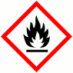 |  |  | 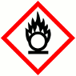 |  |  | 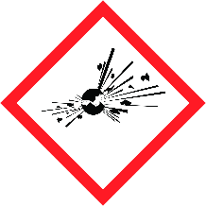 |  |  |  |  |  | 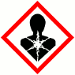 |  |  | 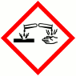
 | FLAMMABLE |  |  | OXIDISING |  |  | EXPLOSIVE |  |  | IRRITANT |  |  | HARMFUL |  |  | CORROSIVE
 | YES | NO |  | YES | NO |  | YES | NO |  | YES | NO |  | YES | NO |  | YES | NO
 | Insert in appropriate boxes
 | 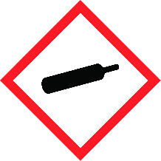 |  |  | 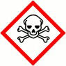 |  |  | 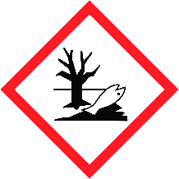
 | COMPRESSED GAS |  |  | TOXIC |  |  | HARMFUL TO THE EINVIRONMENT
 | YES | NO |  | YES | NO |  | YES | NO |  | YES | NO |  | YES | NO |  | YES | NO
Insert in appropriate boxes

Please add comments into boxes where required. |  | Insert in appropriate boxes and add comment below |  | YES | NO
Is Manufacturers Safety Data Sheet available?
Does the Substance have a Workplace Exposure Limit (WEL)?
If the substance has a WEL please state. if un-sure check HSE document – EH40
Can a safer substance be used or can the substance be enclosed or extracted. |  |  | Substance is not classified as hazardous
Will employees be given information and training? |  |  |  | N/A
Will Personal Protective Equipment be provided for employees?
State the standard of RPE (respirators)
State the standard of Goggles or Spectacles
State the standard of Gloves |  |  | Nitrile gloves to be worn
State the standard of Overalls
State the standard of Boots
Other Equipment |  |  | Attach details if YES
Will Exposure Monitoring and/or Control Measures be required? |  |  | Attach details if YES
Will Health Surveillance be necessary? |  |  | Attach details if YES
Does this Substance need to be disposed of by a Waste Disposal Contractor?
Have all necessary First-aid and welfare requirements been provided? |  |  |  | N/A
Have Storage requirements for the substance been provided / arranged on site?
FIRST AID, FIRE FIGHTING, STORAGE & HANDLING, DISPOSAL AND ACCIDENTAL RELEASE INSTRUCTIONS ARE PROVIDED ON PAGES 2 & 3 |  |  | Number of Sheets attached to this Assessment

FIRST AID INSTRUCTIONS
Route of Exposure, or  Type of Injury | First Aid Treatment
Skin Contact | Remove contaminated clothing.  Wash skin thoroughly with soap and water or recognised skin cleaner.  Do NOT use solvents or thinners
Eye Contact | Immediately irrigate copiously with clean water for at least 10 minutes
Inhalation | Remove to fresh air if breathing is irregular or stopped administer artificial respiration.
Ingestion | If swallowed obtain immediate medical attention. Drink copious amounts of fresh water.  Do NOT induce vomiting
General Information | In all cases of doubt, or when symptoms persist, seek medical attention.  * If unconscious place in recovery position, give nothing by mouth.

FIRE FIGHTING MEASURES
Hazard | Measures
Fire | Extinguishing Media: alcohol resistant foam, CO2, powder or water fog.  Never use water jets or water from buckets etc. to fight fire.
Stability | Stable under recommended storage and handling conditions.  .
Decomposition Products | Thermal decomposition or combustion may liberate carbon oxides and other toxic gases or vapours

MANUFACTURERS INFORMATION
Manufacturers Name and Address | MacDermid plc  Palmer Street, Bordesley  Birmingham B9 4EU
Manufacturers Health & Safety Data Sheet Reference | IL61323/163769
24 Hour Emergency Telephone Number | +44 (0)208 762 8322
Regulatory Information: Warning Label Phrases | N/A

STORAGE AND HANDLING
Hazard | Measures
Handling | Nitrile gloves to be worn if prolonged exposure to hands is expected
Storage | Store in tightly closed original container in a cool, dry well-ventilated place. Protect from  freezing. Keep separate from food, feedstuffs, fertilisers and other sensitive material.

DISPOSAL MEASURES
Hazard | Measures
Pollution of water courses or drains | In accordance with Control of Pollution Act  and Environmental Protection Act

ACCIDENTAL RELEASE MEASURES
Hazard | Measures
Spillage | Wear necessary protective equipment. Remove sources of ignition. Absorb spillage with  non-combustible, absorbent material. Collect spillage in containers, seal securely and deliver  for disposal according to local regulations. Runoff or release to sewer, waterway or ground is  forbidden. Inform Authorities if large amounts are involved.

USAGE/EXPOSURE
Frequency and Duration of use | Daily
Maximum number of people involved in activity | 3 employees
Quantities stored/used | 2.5 kg tubs will last up to1 month, depending on usage

Safe System of Work

1. Ensure nitrile gloves are worn when handling

Operatives Acknowledgement

Name: | Signature: | Date: | Name: | Signature: | Date:

