Company Name:  Site: |  | 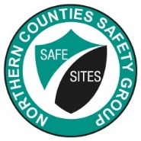 | COSHH  Assessment
Supplier: | Everbuild |  | COSHH Number | 31
 |  |  |  | page 1
Assessment By: | Activity: |  | Review Date | Assessment Date
 | Expanding foam for filling voids
 | Persons/Groups at Risk
 | Operatives, other contractors

NAME OF HAZARDOUS SUBSTANCE USED OR CREATED
EVERBUILD FIX AND FILL EXPANDING FOAM

 | 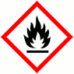 |  |  | 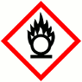 |  |  | 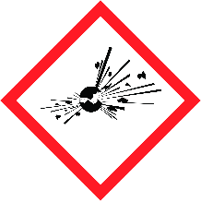 |  |  | 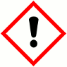 |  |  | 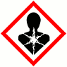 |  |  | 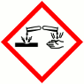
 | FLAMMABLE |  |  | OXIDISING |  |  | EXPLOSIVE |  |  | IRRITANT |  |  | HARMFUL |  |  | CORROSIVE
 | YES | NO |  | YES | NO |  | YES | NO |  | YES | NO |  | YES | NO |  | YES | NO
 | Insert in appropriate boxes
 | 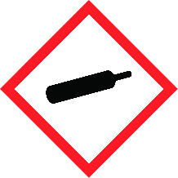 |  |  | 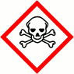 |  |  | 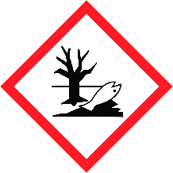
 | COMPRESSED GAS |  |  | TOXIC |  |  | HARMFUL TO THE EINVIRONMENT
 | YES | NO |  | YES | NO |  | YES | NO |  | YES | NO |  | YES | NO |  | YES | NO

Insert in appropriate boxes

Please add comments into boxes where required. |  | Insert in appropriate boxes |  | YES | NO
Is Manufacturers Safety Data Sheet available?
Does the Substance have a Workplace Exposure Limit (WEL)?
If the substance has a WEL please state. if un-sure check HSE document – EH40
Can a safer substance be used or can the substance be enclosed or extracted.
Will employees be given information and training?
Will Personal Protective Equipment be provided for employees?
State the standard of RPE (respirators) |  |  | Not required in well ventilated areas or outdoors
State the standard of Goggles or Spectacles |  |  | BS EN166 safety glasses/goggles
State the standard of Gloves |  |  | Butyl rubber/nitrile rubber gloves
State the standard of Overalls |  |  | Long sleeved clothing, long trousers
State the standard of Boots |  |  | ISO EN20345
Other Equipment |  |  | Attach details if YES
Will Exposure Monitoring and/or Control Measures be required? |  |  | Attach details if YES
Will Health Surveillance be necessary? |  |  | Attach details if YES
Does this Substance need to be disposed of by a Waste Disposal Contractor?
Have all necessary First-aid requirements been provided?
Have Storage requirements for the substance been provided/arranged on site?
FIRST AID, FIRE FIGHTING, STORAGE & HANDLING, DISPOSAL AND ACCIDENTAL RELEASE INSTRUCTIONS ARE PROVIDED ON PAGES 2 & 3 |  |  | Number of Sheets attached to this Assessment

FIRST AID INSTRUCTIONS
Route of Exposure, or  Type of Injury | First Aid Treatment
Skin Contact | Take off contaminated clothing and shoes immediately.  Wash off with soap and plenty of water.  If symptoms persist, call a physician.
Eye Contact | Immediately flush eye(s) with plenty of water.  Remove contact lenses.  Keep eye wide open while rinsing.  If eye irritation persists, consult a specialist
Inhalation | Move to fresh air.
Ingestion | Do not induce vomiting without medical advice.  Rinse mouth with water.  Do not give milk or alcoholic beverages.  Never give anything by mouth to an unconscious person
General Information | Move out of dangerous area.  Consult a physician.  Show this safety data sheet to the doctor in attendance

FIRE FIGHTING MEASURES
Hazard | Measures
Fire | Use extinguishing measures that are appropriate to local circumstances  and the surrounding environment. Unsuitable extinguishing media: Water
Stability | The product is chemically stable.
Decomposition Products | None

MANUFACTURERS INFORMATION
Manufacturers Name and Address | Everbuild – A Sika Company  Site 41  Knowsthorpe Way  Cross Green Industrial Estate  Leeds  West Yorkshire LS9 0SW
Manufacturers Health & Safety Data Sheet Reference | N/A
24 Hour Emergency Telephone Number | 0044 113 240 3456 (office hours only)
Regulatory Information: Warning Label Phrases | H222: Extremely flammable aerosol.  H229: Pressurised container: May burst if heated.  H332: Harmful if inhaled.  H315: Causes skin irritation.  H319: Causes serious eye irritation.  H332 Harmful if inhaled.  H334: May cause allergy or asthma symptoms or  breathing difficulties if inhaled.  H317: May cause an allergic skin reaction.  H351: Suspected of causing cancer.  H335: May cause respiratory irritation  H373 May cause damage to organs through prolonged  or repeated exposure if inhaled.  P101 If medical advice is needed, have product  container or label at hand.  P102 Keep out of reach of children.  P210 Keep away from heat, hot surfaces, sparks, open flames and other ignition sources. No smoking.  P211 Do not spray on an open flame or other ignition source.  P251 Do not pierce or burn, even after use.  P260 Do not breathe dust/ fume/ gas/ mist/ vapours/spray.  P271 Use only outdoors or in a well-ventilated area.  P280 Wear protective gloves/ protective clothing/eye protection/ face protection.  P304 + P340 + P312 IF INHALED: Remove person to fresh  air and keep comfortable for breathing. Call a POISON CENTER/doctor if you feel unwell.  P308 + P313 IF exposed or concerned: Get medical advice/  attention.  P405 Store locked up.  P410 + P412 Protect from sunlight. Do not expose to temperatures exceeding 50 °C/ 122 °F.

STORAGE AND HANDLING
Hazard | Measures
Handling | Do not get in eyes, on skin, or on clothing. Persons with a history of skin sensitisation problems or asthma, allergies, chronic or recurrent respiratory disease should not be employed in any  process in which this mixture is being used. Smoking, eating and drinking should be prohibited in the application area. Take precautionary measures against static discharge. Provide  sufficient air exchange and/or exhaust in work rooms. Open drum carefully as content may be under pressure. Follow standard hygiene measures when handling chemical products. Keep away from heat/sparks/open flames/hot surfaces. No smoking. Do not spray on a naked flame or any incandescent  material. Take precautionary measures against electrostatic discharges.
Storage | BEWARE: Aerosol is pressurized. Keep away from direct sun exposure and temperatures over 50 °C. Do not open by force or throw into fire even after use. Do not spray on flames or  red-hot objects. Store in original container. Keep container tightly closed in a dry and well-ventilated place. Observe label precautions. Store in accordance with local regulations.

DISPOSAL MEASURES
Hazard | Measures
Pollution of water courses or drains | Absorb spillage with non-combustible, absorbent material. Collect and place in suitable waste disposal containers and seal securely. Flush contaminated area with plenty of water.  Do not allow to enter water courses or drains.

ACCIDENTAL RELEASE MEASURES
Hazard | Measures
Spillage | Use personal protective equipment. Deny access to unprotected persons.  Do not flush into surface water or sanitary sewer system. If the product contaminates rivers and lakes or drains inform respective authorities. 15 01 10* packaging containing residues of or contaminated  by dangerous substances

USAGE/EXPOSURE
Frequency and Duration of use | Weekly up to 2 hours
Maximum number of people involved in activity | 2
Quantities stored/used | 6 x 750ml can
Exposure levels | Unlikely to be exceeded in normal use in well ventilated areas or outdoors.

Safe System of Work

1. All correct PPE to be worn, particularly gloves and eye protection.

2. Ensure skin is covered on arms. Avoid skin contact.

3. No smoking or naked flames. Highly flammable.

4.

5.

6.

7.

8.

9.

10.
Operatives Acknowledgement

Name: | Signature: | Date: | Name: | Signature: | Date:

