Company Name:  Site: |  |  | COSHH  Assessment
Supplier: | Bostik |  | COSHH Number | 33
 |  |  |  | page 1
Assessment By: | Activity: |  | Review Date | Assessment Date
 | Sealing bonding and filling various materials.
 | Persons/Groups at Risk
 | User

NAME OF HAZARDOUS SUBSTANCE USED OR CREATED
Substance: Silicone Sealant

 | 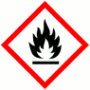 |  |  | 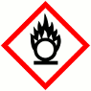 |  |  | 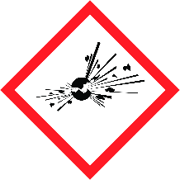 |  |  | 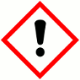 |  |  | 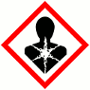 |  |  | 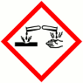
 | FLAMMABLE |  |  | OXIDISING |  |  | EXPLOSIVE |  |  | IRRITANT |  |  | HARMFUL |  |  | CORROSIVE
 | YES | NO |  | YES | NO |  | YES | NO |  | YES | NO |  | YES | NO |  | YES | NO
 | Insert in appropriate boxes
 | 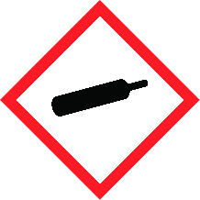 |  |  | 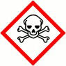 |  |  | 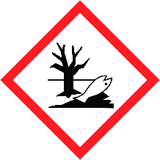
 | COMPRESSED GAS |  |  | TOXIC |  |  | HARMFUL TO THE EINVIRONMENT
 | YES | NO |  | YES | NO |  | YES | NO |  | YES | NO |  | YES | NO |  | YES | NO

Insert in appropriate boxes

Please add comments into boxes where required. |  | Insert in appropriate boxes and add comment below |  | YES | NO
Is Manufacturers Safety Data Sheet available?
Does the Substance have a Workplace Exposure Limit (WEL)?
If the substance has a WEL please state. if un-sure check HSE document – EH40
Can a safer substance be used or can the substance be enclosed or extracted.
Will employees be given information and training?
Will Personal Protective Equipment be provided for employees?
State the standard of RPE (respirators)
State the standard of Goggles or Spectacles |  |  | If risk of splashing use goggles or face shield
State the standard of Gloves |  |  | Rubber Gloves
State the standard of Overalls
State the standard of Boots
Other Equipment |  |  | Attach details if YES
Will Exposure Monitoring and/or Control Measures be required? |  |  | Attach details if YES
Will Health Surveillance be necessary? |  |  | Attach details if YES
Does this Substance need to be disposed of by a Waste Disposal Contractor?
Have all necessary First-aid and welfare requirements been provided?
Have Storage requirements for the substance been provided / arranged on site?
FIRST AID, FIRE FIGHTING, STORAGE & HANDLING, DISPOSAL AND ACCIDENTAL RELEASE INSTRUCTIONS ARE PROVIDED ON PAGES 2 & 3 |  |  | Number of Sheets attached to this Assessment

FIRST AID INSTRUCTIONS
Route of Exposure, or  Type of Injury | First Aid Treatment
Skin Contact | Wash skin with plenty of warm water. Seek medical advice.
Eye Contact | Flush the eyes for 10 minutes with clean running water. Seek medical advice.
Inhalation | Remove to fresh air and keep casualty warm and at rest. Take to hospital if breathing difficulties occur.
Ingestion | Seek medical advice and do not induce vomiting
General Information | Strong Ammonia type smell

FIRE FIGHTING MEASURES
Hazard | Measures
Fire | This product is not flammable. Use fire-extinguishing media appropriate for surrounding materials.
Stability | Stable under normal temperature conditions.
Decomposition Products | Fire creates: Carbon monoxide (CO). Carbon dioxide (CO2).

MANUFACTURERS INFORMATION
Manufacturers Name and Address | BOSTIK LIMITED  COMMON ROAD  STAFFORD  STAFFORDSHIRE  ST16 3EH
Manufacturers Health & Safety Data Sheet Reference | SKU 240702, 243801
24 Hour Emergency Telephone Number | +44 1785 272650
Regulatory Information: Warning Label Phrases | R65 Harmful: may cause lung damage if swallowed.  R66 Repeated exposure may cause skin dryness or cracking  H304 May be fatal if swallowed and enters airways. EUH066 Repeated exposure may cause skin dryness or cracking.

STORAGE AND HANDLING
Hazard | Measures
Handling | Do not handle broken packages without protective equipment. Use mechanical ventilation in case of handling which causes formation of dust. Avoid spilling, skin and eye contact
Storage | Store in cool, dry conditions. Protect from freezing.

DISPOSAL MEASURES
Hazard | Measures
 | Dispose of in a designated skip to be transported by a Waste Transfer Licensed Company.

ACCIDENTAL RELEASE MEASURES
Hazard | Measures
 | Stop leak if possible without risk. Do not contaminate water sources or sewer. Pick up with vacuum or absorbent solid, store in closed container for disposal. Avoid generation and spreading of dust. Avoid contact with skin or inhalation of spillage, dust or vapour. Wear necessary protective equipment. Containers with collected spillage must be properly labelled with correct contents and hazard symbol.

USAGE/EXPOSURE
Frequency and Duration of use
Maximum number of people involved in activity
Quantities stored/used
Exposure levels

Safe System of Work

1.

2.

3.

4.

5.

6.

7.

8.

9.

10.

Operatives Acknowledgement

Name: | Signature: | Date: | Name: | Signature: | Date:

