Bosun’s Chairs Policy
Boatswain’s (or bosun’s) chairs should only be used where the work is of a relatively short duration and where no other means of access or working, such as a suspended scaffold, is practicable.
A person in a boatswain’s chair is extremely vulnerable. They are suspended high above the ground and, if anything goes wrong, the chances are that they are beyond rapid or immediate help. The risk assessment should cover rescue procedures should an emergency occur.
The installation and use of a boatswain’s chair must be supervised by an experienced and competent person. Only properly trained and competent operatives should be permitted to use them. The regulations must be strictly observed.
The traditional non-British Standard boatswain’s chair is still used by specialist trades such as steeplejacks and lightning conductor engineers. Operatives need to be fully trained and competent before being permitted to use and work from it.
Where possible, consideration should be given to the provision of a second safety line connected to a harness being worn by the operative. In this way, should there be a problem with the boatswain’s chair, this safe system of working will prevent a fall. It may not always be possible and if this is the case, then the reason for this should be recorded as part of the work at height risk assessment.

Rigging
In the construction industry, a boatswain’s chair should always be rigged with a pair of single sheave pulley block, having a safe working load of at least 225kg. Outriggers and other supports must be strong enough, and be securely fastened down. Where weights are used, a safety factor of four is required.
A boatswain’s chair is classified as a ‘roped access system’ under the Work at Height Regulations 2005. Therefore, the system should be rigged with a separately anchored safety line complete with an automatic locking device attached to the user of the seat that prevents or limits a fall should the primary suspension system fail.

Chair
A boatswain’s chair should meet the following requirements:
- Compliance with BS 2830. A certificate of compliance should be available from the manufacturer
- Be of a recommended size:
- Between 450 mm and 60 mm wide
- Not less than 225 mm deep
- Have a back not less than 250 mm high

Chair (continued)
- If the chair has a single central leg or suspension member, this should be without sharp bends and be securely fixed to the seat as far back as practicable, so that the user sits with one leg at either side
- To be provided with a safety harness to prevent the occupant falling out
- The back and the suspension member should be placed so that no-one can fall out
- The suspension point must be at least 500 mm above the seat, with provisions for suspension. No part should be able to become detached
- Be made for a safe working load of 115 kg. A proof test of 150 kg is recommended

Protection of the public
When the risk assessment indentifies that work from a boatswain’s chair will take place above areas where people may be present, adequate protection must be installed to prevent them being injured from falling equipment or materials. This is reinforced by the requirement for the creation and management of ‘danger areas’ under The Work at Height Regulations 2005, also see HSG 151

Design and Safety Factor
Designs must be produced for the cantilever arrangement through the provider or from manufacturer’s guidance. The design must also consider the suitability of the roof to transfer the loads. The counterweight (W) x tail length (T) should be at least four times the projection length (O) x weight of person, the chair and any tools or equipment being carried (C).

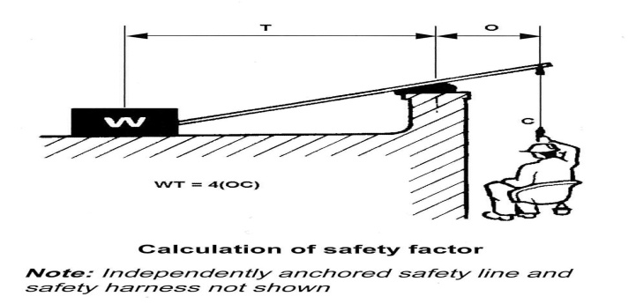

Hooks
Hooks should be fitted with a spring-loaded device to prevent the displacement of the load.

Lifting Equipment
All ropes and chains used should be thoroughly examined under LOLER (see below) before their first use for any sign of chafing or wear, and then every six months. They must be securely attached to the chair and the anchor. Swivel connections should be used to prevent spinning.
Fall ropes should not be less than 18 mm in diameter. They should be tied off correctly in the working position. The rope must not be removed from the cleat while the chair is in use. A controlled descent is achieved by removing the locking-hitch from the rope in the ‘tied-off’ position and easing it around the cleat.
All lifting equipment and ancillary equipment must conform to The Lifting Operations and Lifting Equipment Regulation 1998.

